**Unit Strategic Plan**

**2019- 2021**

**Name of Program/Department: Manufacturing and Technology**

**Mission Statement:**

The Manufacturing Technology Center programs include the following program options:

1. Industrial Technology
2. Biomedical Equipment ***(Note Biomedical Equipment Unit Goals are covered in a dedicated Unit Strategic Plan)***
3. Automotive/Automated Manufacturing
4. Electronics
5. Computer Aided Drafting and Design.
6. Welding Technology
7. Manufacturing Systems Technology

The mission of this department is to provide all learners access to quality STEAM-related technical educational opportunities and experiences that will meet the ever-changing and increasing demands of manufacturing and general industry.

The department will:

* Provide Associate in Applied Science (AAS) degree programs and career certificates that enable graduates to obtain gainful employment.
* Expand learning opportunities through the integration of technology with instruction.
* Provide courses that help those already employed acquire specialized skills needed as a result of technological advances and/or for job advancement.
* Evaluate programs and courses for relevancy, ensure that they meet the current and future needs of local industries, and make appropriate changes as needed.
* Maintain a professional and knowledgeable faculty.
* Support Secondary Education in providing articulated dual-credit courses.
* Support Secondary Education in informing students of available Career Pathways in STEAM- related technical careers.
* Keep abreast of statewide and regional workforce development initiatives that meet the needs of industry and develop appropriate plans including pursuing grants to meet those needs. The major initiative associated with statewide and regional workforce development is manufacturing based apprenticeships.
* Keep abreast of national STEAM initiatives that meet the needs of local industry and develop appropriate plans including pursuing grants, such as National Science Foundation (NSF) awards, to meet those needs.

**Summary of Access, Productivity and Effectiveness (NEED REVISED DATA)**



**Total Registrations by Semester**

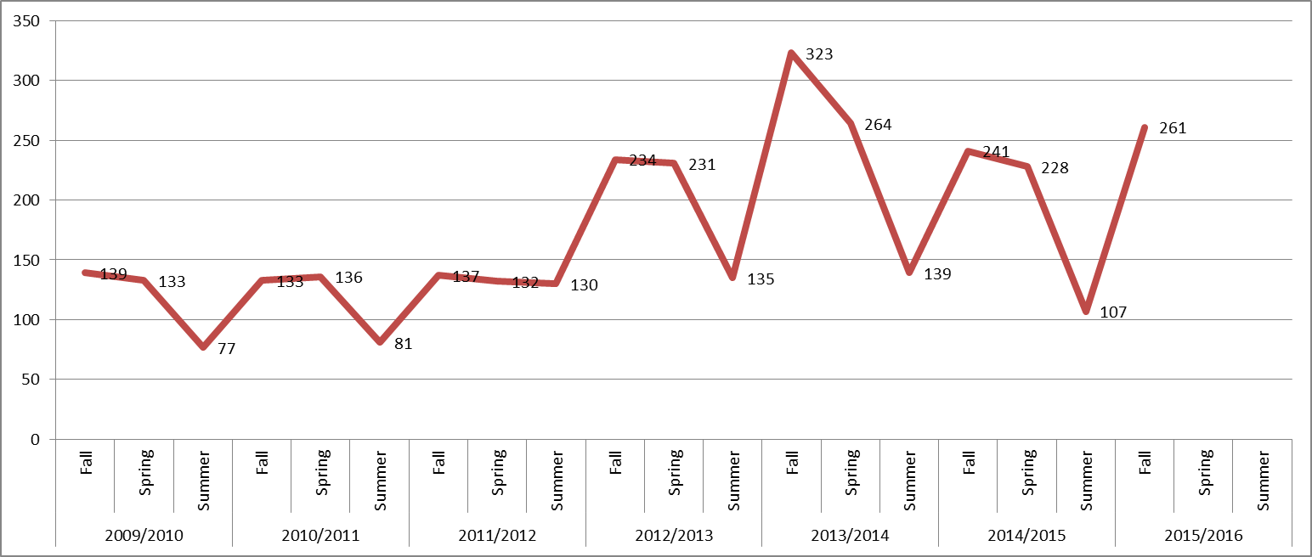

**Total Awards**

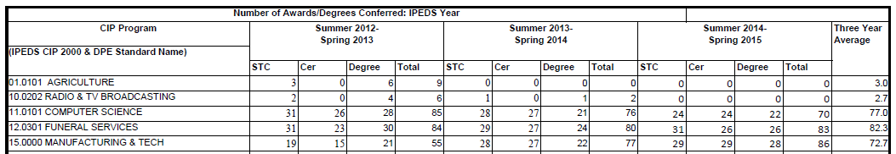

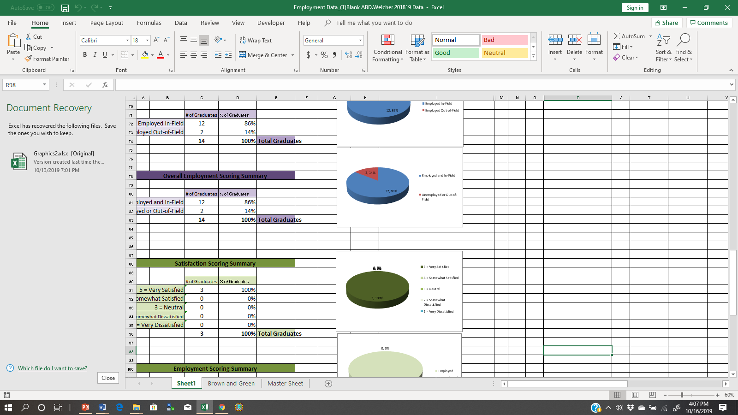 **Recent survey of Spring 2019 Manufacturing & Technology AAS Degree Graduates:**



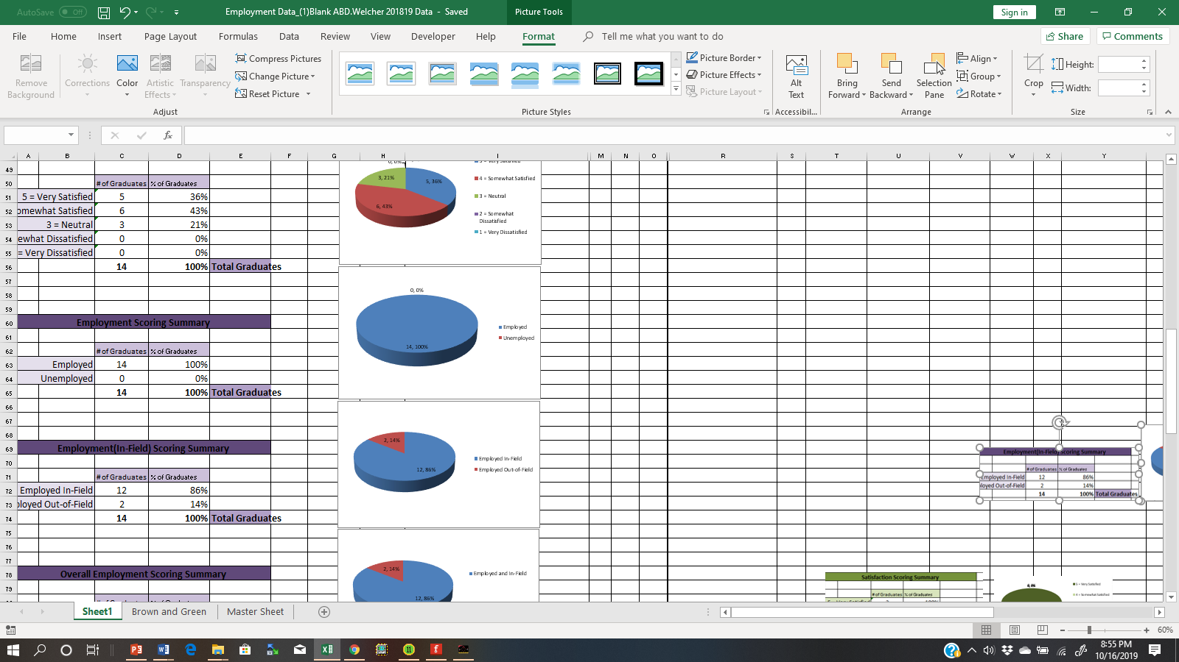



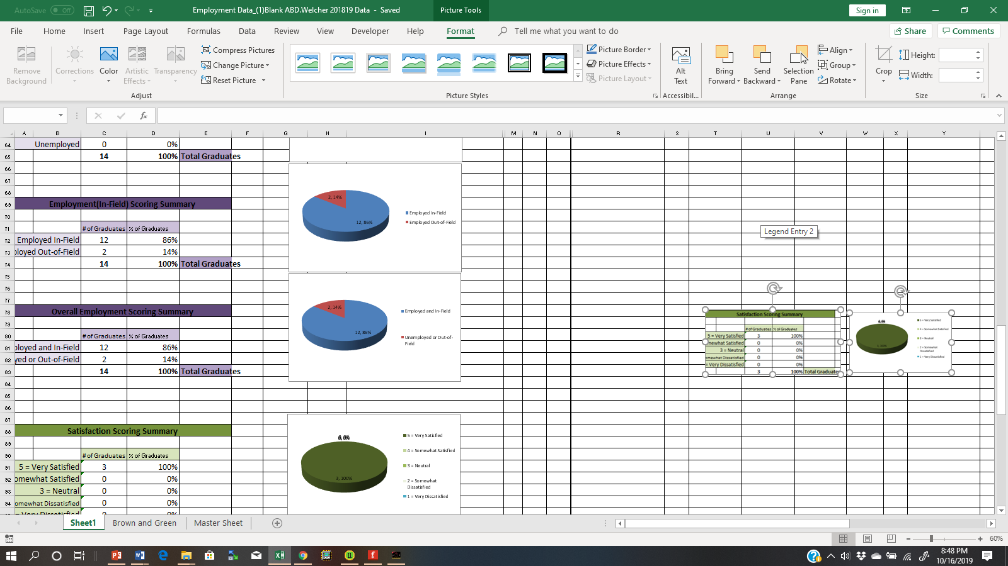

**Internal Conditions:**

1. **Technology**
2. **Computer & Peripherals Technology**

**Lecture Rooms:** Currently, three lecture classrooms (116 and 230) are equipped with SmartBoards. The SmartBoard allows Internet access along with the ability to share whiteboard notes using Bluetooth Technology. The CADD lab uses an LCD projector/audiovisual equipment for use during class lectures. The St. Clair-Pell City Campus uses an LCD projector/audiovisual equipment for instructional technology as well. The instructional goal is to use SmartBoards throughout the Manufacturing Technology Building. Therefore, classrooms 106, 124, 226, and 232 will need to be upgraded to with SmartBoards to improve pedagogy practices for the technical instructional staff. The St. Clair-Pell City Campus will need a SmartBoard as well. This is an increasing need as most courses now have audio visual developed curriculum.

**CADD Lab:** The CADD lab requires Windows 10 computers to operate the 2D and 3D Modeling application software use in the CADD option. The current computers at the near product life expectancy. The computer hardware such as the hard drive has reached it warranty period for support. Therefore, the computers will need to be upgraded to Windows 10 Operating Systems (OS) to handle the latest 2D and 3D modeling applications.

**Office Computers:** The front office has been replaced due to the product life expectancy of the desktop personal computer’s motherboard. The part-time instructor office computer is enough for the current application software and operating system being used.

**Instructor Computers:** Full-time instructors are issued laptops for both instructional and office use. The two welding instructors’ have received new laptop computers to support their instructional needs in the classroom and offsite training courses.

***Up to two additional laptops will be required*** *for new instructors requested below.*

**Printers:** At the Jefferson Campus, current printers are sufficient for the current application software and operating system being used. *A printer has been included for the general lab areas at the Manufacturing Center and the* St. Clair-Pell City Campus*.*

**Manufacturing Technology Specific Application software:**  With input from the advisory committees, consideration of industry trends, the faculty recommends software upgrades as needed.

**b. Instructional Systems Trainers and Labs (Jefferson Campus: Manufacturing and Technology Center Building)**

**Programmable Logic Controllers Lecture/ Lab (Room 106)**

The Programmable Logic Controllers (PLCs) Lecture/Lab consist of a lecture and lab learning environment. The PLC Lecture/Lab allow instructional content to be delivered to Industrial Technology and Automotive\Automated Manufacturing technical learners the opportunity to obtain cognitive and psychomotor skills in programming Allen Bradley (AB) SLC500 family of PLCs. The PLC Lecture/Lab supports the Introduction to Programmable Logic Controllers (ATM 211) and Advanced Programmable Logic Controllers (ATM 212) courses. There are seven workstations with the AB SLC500 mounted on and wired to Amatrol Simulators. The Amatrol Simulators have eight discrete electric switches and eight Light Emitting Diodes (LEDs) indicators allowing technical learners to obtain visual feedback of their Ladder Logic programs. Also, motor control and pneumatic circuit simulators are used to simulate various automation systems in the technical learning environment.

**CADD Lab (Room 114)**

The CADD lab requires Windows 10 computers to operate the 2D and 3D Modeling application software use in the CADD option. The current computers at the near product life expectancy. The computer hardware such as the hard drive has reached it warranty period for support. Therefore, the computers will need to be upgraded to Windows 10 Operating Systems (OS) to handle the latest 2D and 3D modeling applications. Also, there is a Hexagon Portable Coordinate Measuring Machine (PCMM) to instruct Manufacturing Systems Technology technical learners on visual and automated measuring techniques using PCMM technology. The Automated Inspection Principles (MET 237) course supports the instructional content material using the software-based inspection technology.

**Electromechanical Lab (Room 108)**

The Electromechanical Lab consist of several industrial based systems training learning environments. The Electromechanical Lab allow instructional content to be delivered to Automotive\Automated Manufacturing, Industrial Technology, Electronics, Computer Aided Drafting/Design, and Manufacturing Systems Technology technical learners the opportunity to obtain cognitive and psychomotor skills in wiring and troubleshooting industrial motor controls, DC and AC circuits, advanced motor drives, electrohydraulic, and electropneumatic circuits. The Electromechanical Lab supports the following instructional technical courses.

* ATM 220 Advanced Motor Drives
* AUT 209 Automated Systems Diagnosis & Troubleshooting
* ELM 215 Industrial Controls I
* IET 114 Basic Electricity
* ELM 200 Electric Circuits I
* ELM 201S Electric Circuits II
* AUT130 Fundamentals of Hydraulics and Pneumatics
* MET220 Mechanical Systems I

Also, technical learners obtain hands-on mechanical knowledge on an Amatrol Mechanical Drive Systems trainer. The industrial systems trainers that support the hands-on instruction in the Electromechanical Lab are listed next.

* (4) Amatrol Motor Controls trainers
* (3) LabVolt AC/DC electrical trainers
* (4) Amatrol hydraulics trainers
* (3) Amatrol Pneumatics trainers
* (4) Amatrol Advanced Motor Drive trainers
* (4) Amatrol Mechanical Drive Systems trainers
* (2) Amatrol Measurement Tools Unit

Also, technical learners will learn troubleshooting and diagnosis skills using an Amatrol Mechatronics Systems trainer. The Amatrol Mechatronics Systems trainer has seven process stations, a Siemens Simatic Human Machine Interface (HMI), seven Siemens Simatic S3-700 PLCs, and on Fanuc industrial table top 6 Degrees of reedom (DOF) robot. The seven stations are attached to each and communicate digitally using ethernet cables.

**Robotics Labs (Rooms 124 and 090 )**

The Robotics Lab consist of five Asea Brown Broveri (ABB) robotic arm stations. In room 124, two of the robots are STEM based mobile training units enclosed in a plexiglass work cell. The remainder three table top robots are mounted on structurally sound tables. Each station includes a teach pendant and robotics controller. Also, industrial conveyor simulators are included with each robot arm station for instructing technical learners on industrial robotic based systems The Robotics Lab allow instructional content to be delivered to Automotive\Automated Manufacturing, Welding Technology, Manufacturing Systems Technology, and Industrial Technology technical learners the opportunity to obtain cognitive and psychomotor skills in programming and coding robot programs with a teach pendant. The Robotic Lab supports the following instructional technical courses.

* AUT 116 Introduction to Robotics
* AUT 213 Robotics Projects

In addition, Room 090 houses two Fanuc Welding Robots. The two welding robots are used to instruct technical learners on robotics-based welding applications. The instruction includes programming and debugging robot programs for welding robotics applications.

**Machine Shop (Room 118)**

The Machine Shop consist of several industrial subtractive manufacturing machines. These machines are listed next.

* (5) Lathes
* (1) Cutoff Saw
* (1) Bandsaw
* (1) CNC Machine
* (3) Drill Presses
* (1) Metal Grinder
* (1) Table Grinder

Besides subtractive manufacturing machines, the Machine Shop is stocked with measuring gauges (micrometers and calipers: dial and digital), scales, drill and milling bits, chucks, bandsaw blades, grinding wheels and cutoff saw blades. These industrial based manufacturing machines, supporting gauges, bits, and cutting products instruct Welding Technology, Manufacturing Systems Technology, Computer Aided Drafting/Design, Industrial Technology, and Biomedical Equipment Technology technical learners on proper procedures for best machining practices. The Machine Shop supports the following instructional technical courses.

* Mechanical Tools I
* Mechanical Tool II

In addition, a Rigging Trainer is housed in the Machine shop for instructing technical learners on proper material handling practices of small industrial machines and equipment using an electric rigger.

**Welding Lab (Ruby Carson Building: Room 007)**

The Jefferson State Campus supports education and technical hands-on training in welding technology. There are 20 welding stations that uses Lincoln TIG Welding Machines. Also, each station provides an assortment of power and manual tools for welding technology learners to use for in class activities and projects such as the fabrication of coupons. In addition, there is a metal grinder, horizontal bandsaw, mechanical pull tester, plasma cutter, portable hand grinders, shearing machine, and an electric track welder to support welding education and training of the enrolled technical learners. The welding technology lab supports the following technical courses.

* WK0 110 NCCER Core
* WDT 120 Shielded Metal Arc Welding Groove
* AUT 186 Principles of Industrial Maintenance Welding and Metal Cutting Techniques
* WDT 109 SMAW Fillet/PAC/CAC
* WDT 119 Gas Metal Arc/Flux Cored Arc Welding
* WDT 166 Flux Core Arc (FCAW)
* WDT 219 Welding Inspection and Testing Theory

Also, a rigging trainer supports the WKO 110 NCCER Core course on providing Material Handling instruction to welding technology learners.

**Electronics Technology Lab (George Layton Nursing Building: Room 021B)**

The Electronics Technology Lab consist of twenty- five Nida Corporation industrial based electronics trainer learning environment. The newly renovated electronics lab consists of State-of-the-Art touch screen Nida Corporation trainers. The Electronics Technology Lab allow instructional content to be delivered to Automotive\Automated Manufacturing, Industrial Technology, Computer Aided Drafting/Design, and Biomedical Equipment Technology technical learners the opportunity to obtain cognitive and psychomotor skills in testing, analysis, troubleshooting of DC, AC electrical circuits, basic analog and digital electronics technologies. The Electronics Technology Lab supports the following instructional technical courses.

* ELM 205 Basic Electronics I
* ELM 202 Digital Circuits
* IET 114 Basic Electricity
* ELM 200 Electric Circuits I
* ELM 201S Electric Circuits II

1. **Instructional Systems Trainers and Labs (Pell City Campus: iCademy)**

The iCademy is an open floor facility that supports the Pell City Industrial community with entry level skilled and trades professionals educated in a variety of technical arenas. The following paragraphs provide descriptive narratives on the instructional technologies used to prepare our technical learners for the Pell City 21st industrial and manufacturing employment opportunities available.

**Programmable Logic Controllers Lecture/ Lab**

The Programmable Logic Controllers (PLCs) Lecture/Lab consist of a lecture and lab learning environment. The PLC Lecture/Lab allow instructional content to be delivered to Industrial Technology and Automotive\Automated Manufacturing technical learners the opportunity to obtain cognitive and psychomotor skills in programming Allen Bradley (AB) SLC500 family of PLCs. The PLC Lecture/Lab supports the Introduction to Programmable Logic Controllers (ATM 211) and Advanced Programmable Logic Controllers (ATM 212) courses. There are seven workstations with the AB SLC500 mounted on and wired to Amatrol Simulators. The Amatrol Simulators have eight discrete electric switches and eight Light Emitting Diodes (LEDs) indicators allowing technical learners to obtain visual feedback of their Ladder Logic programs. Also, motor control and pneumatic circuit simulators are used to simulate various automation systems in the technical learning environment.

**Robotics Labs**

The Robotics Lab consist of four Asea Brown Broveri (ABB) robotic arm stations. The ABB robots are STEM based mobile training units enclosed in a plexiglass work cell. The Robotics Lab allow instructional content to be delivered to Automotive\Automated Manufacturing, Welding Technology, Manufacturing Systems Technology, and Industrial Technology technical learners the opportunity to obtain cognitive and psychomotor skills in programming and coding robot programs with a teach pendant. The Robotic Lab supports the following instructional technical courses.

* AUT 116 Introduction to Robotics
* AUT 213 Robotics Projects

**Electromechanical Lab**

The Electromechanical Lab consist of several industrial based systems training learning environments. The Electromechanical Lab allow instructional content to be delivered to Automotive\Automated Manufacturing, Industrial Technology, Electronics, Computer Aided Drafting/Design, and Manufacturing Systems Technology technical learners the opportunity to obtain cognitive and psychomotor skills in wiring and troubleshooting industrial motor controls, DC and AC circuits, advanced motor drives, electrohydraulic, and electropneumatic circuits. The Electromechanical Lab supports the following instructional technical courses.

* ATM 220 Advanced Motor Drives
* AUT 209 Automated Systems Diagnosis & Troubleshooting
* ELM 215 Industrial Controls I
* IET 114 Basic Electricity
* ELM 200 Electric Circuits I
* ELM 201S Electric Circuits II
* AUT130 Fundamentals of Hydraulics and Pneumatics
* MET220 Mechanical Systems I

Also, technical learners obtain hands-on mechanical knowledge on an Amatrol Mechanical Drive Systems trainer. The industrial systems trainers that support the hands-on instruction in the Electromechanical Lab are listed next.

* (3) LabVolt AC/DC electrical trainers
* (3) Amatrol hydraulics trainers
* (1) Amatrol Pneumatics trainer
* (2) Amatrol Mechanical Drive Systems trainers
* (2) Amatrol Measurement Tools Unit

Also, technical learners will learn troubleshooting and diagnosis skills using an Amatrol Mechatronics Systems trainer. The Amatrol Mechatronics Systems trainer has seven process stations, a Siemens Simatic Human Machine Interface (HMI), seven Siemens Simatic S3-700 PLCs, and on Fanuc industrial table top 6 Degrees of Freedom (DOF) robot. The seven stations are attached to each and communicate digitally using ethernet cables.

**Welding Lab Stations**

The Pell City Campus iCademy facility supports education and technical hands-on training in welding technology. There are 10 welding stations that uses Lincoln TIG Welding Machines. Also, each station provides an assortment of power and manual tools for welding technology learners to use for in class activities and projects such as the fabrication of coupons. In addition, there is a metal grinder, horizontal bandsaw, and an electric track welder to support welding education and training of the enrolled technical learners. The welding technology lab supports the following technical courses.

* WK0 110 NCCER Core
* WDT 120 Shielded Metal Arc Welding Groove
* AUT 186 Principles of Industrial Maintenance Welding and Metal Cutting Techniques
* WDT 109 SMAW Fillet/PAC/CAC
* WDT 119 Gas Metal Arc/Flux Cored Arc Welding
* WDT 166 Flux Core Arc (FCAW)
* WDT 219 Welding Inspection and Testing Theory

Also, a rigging trainer supports the WKO 110 NCCER Core course on providing Material Handling instruction to welding technology learners.

1. **Budget**

The budget for classroom and office supplies is currently sufficient. Classroom/lab and faculty computer/ printers are scheduled for replacement on a rotational basis. Additional funds are needed to support equipment upgrades and startup of the recently approved Welding Technology and to support acquisition of equipment to allow full obtainment of AAS degree options at the St. Clair-Pell City Campus. Also, funds will be required for the Fall 2016 roll-out of the Manufacturing Systems Technology option. Paragraph 7 details the aforementioned equipment needs.

1. **Staffing**

**Department Administration:** The Director level position has been filled to manage the increased duties and responsibilities due to growth and job responsibilities. The Director level position is strategically supported to handle the increased state-wide emphasis/visibility of workforce education and training by the ACCS and its new Board of Trustees and by the Alabama Department of Workforce Development support the justification of a higher respected position title to help advance external and internal stakeholder approvals of JSCC/department goals and funding requests.   
 **Full-Time Instructors:** The Manufacturing and Technology program is currently staffed with four full-time faculty, one of which also serves as the Director. Three of the fulltime instructors are stretched between both the Jefferson and St. Clair-Pell City campuses.

***The program has hired a full-time welding instructor*** for the Welding Technology AAS degree option.

***The program requests an additional full-time manufacturing and technology instructor for the Federation of Advanced Manufacturing Education.*** The FAME Curriculum is industry specific which requires complete instructional attention and delivery of subject content to the technical learning environment by an instructor. Therefore, such a structure curriculum requires the dedication and commitment of a fulltime FAME instructor. Also, for the Fall 2019 semester, the part-time instructor credit-hour production percentage for all courses held, including Biomedical Equipment Technology and Dual Enrollment classes is expected to be approximately 55%. For the Manufacturing Technology only classes at the Jefferson Campus, the part-time percentage is expected to be approximately 65%. Due to the growth of the program in options being offered and in registrations at both the Jefferson and St. Clair-Pell City campuses, and the growth of dual enrollment, an additional full-time instructor will be required.

**Part-time Lab Assistant (L19):** The program is currently staffed withtwo part-time lab assistants. These lab assistants are primarily assigned to the late afternoon/evening hours to support night classes at the Jefferson campus. There are over 20 active courses requiring use of lab equipment/trainers, materials, and expendables. Responsibility include keeping up the lab rooms, ensuring equipment and tools stay in good repair, keeping the training lab books up to date, ensuring a safe environment, inventorying, ordering supplies, interfacing with instructors to set up labs for the classes, and assisting students needing help in executing their labs.

***The program requests one additional fulltime lab assistant for the 2019-2020 academic year*** to support day-time operations, to support the department goal of implementing “open-labs” for increased student access, and to support student flexible work schedules. Additional responsibilities will include support of the roll-out and ongoing operation of the Welding Technology and Manufacturing Technology Systems options.

1. **Resources**  
     
   **MSSC Grant:** The Manufacturing Technology Center receives an annual MSSC Grant to support learners obtaining training in Production Technology. The grant funds learners taking the technical assessments in the subject areas of Safety, Quality, Manufacturing Process and Methods, and Maintenance Awareness. The grant allows learners to obtain credentials in these four technical areas. Upon receiving the four credentials, learners will obtain the status of a Certified Production Technician. Also, dual enrollment learners are eligible to receive the same educational benefits from this educational grant funding source. The MSSC Grant supports the following courses that leads to obtaining industry recognized credentials by technical learners.

* ADM 106 Quality Control Concepts (MSSC Credential: Quality Practices & Measurement)
* AUT 102 Lean Manufacturing & Industrial Safety (MSSC Credential: Safety)
* AUT 144 Manufacturing Systems, Methods, and Processes (MSSC Credential: Manufacturing Processes and Production)
* MET 220 Mechanical Systems I (MSSC Credential: Maintenance Awareness)

**Women in Manufacturing Initiative (WMI):** The Manufacturing Technology Department receives educational grants from our Industry Partners in support of female leaners enrolled in AAS technical degree options listed in Mission Statement’s section. The grant supports female technical learners needing assistance in obtaining books and other educational materials needed for their instructional courses. The two industry partner sponsors of grants include:

* Recursion Program
* Altec Company

**The Appalachian Regional Commission (ARC) Grant:** ARC has provided financial support through generous grants to improve technical instruction. The grants supported the financial purchase of two State of the Art Amatrol Mechanical Drive Systems trainers. These trainers support technical learners in obtaining cognitive knowledge and psychomotor skills on theory and applications of mechanical drives systems. Also, the Biomedical Equipment Technology program received a renovation grant to upgrade the Nida Electronics Lab with State-of-the-Art touch screen-based trainers, 3D printers, and desktop Virtual Reality Simulators. In addition, *The* *George Layton Nursing Building: Room 021B* was renovated to accommodate the 25 Nida Electronics Lab workstations. The ARC grant provided funding for the new Nida Electronics Lab renovation project.

**The Alabama Community College Systems (ACCS) Grant:** The ACCS has supported the MSCC Certified Production Technician Assessments initiatives through funded generous grants. Also, the Academic 2018-2019 STEAM camp was funded by an ACCS grant.

**The National Science Foundation (NSF) Advanced Technological Education (ATE) Grant:**

NSF ATE provides advanced technician education support through generous grant funding. With such a grant, Jefferson State Community college was able to obtain a 2017-2019 grant to improve Production Technology within the Industrial Technology and Manufacturing Systems Technology AAS degree options programs. The grant allowed the purchased of two Amatrol Mechanical Drive Systems Drives to support the MET220 Mechanical Systems I course. Also, the grant supported a technical staff to manage the production technology enhancements consisting of a Principal Investigator (PI), Co-PI, and a Lab Assistant.

**STEAM Camps:**  The ACCS grant funded the Academic 2018-2019 STEAM camp for local High School students. The week-long camp exposes the attendees of the technologies used in manufacturing including: Python Coding, Microcontrollers, Robotics, CADD, PLCs, Electronics, and Welding. Also, these hands- on sessions will inform the participating learners available Career Paths in the STEAM related industries.

1. **Enrollment (NEED DATA FOR (2015-2019)**

Course offerings are adjusted with respect to current enrollment trends. Registrations increased approximately 30% in the current two plan period (2013-2015, 1,302 registrations) from the previous two year plan period (2011-2013), 999 registrations).

1. **Facility**

**Jefferson Campus**

The Welding Technology option enrollment will require additional space at the Jefferson Campus. Currently, the lab has reached its space capacity to ensure the safety and effective hands-on instruction in the classroom and lab***.***

**Shelby-Hoover Campus**

A new welding lab is under construction to accommodate the need for welders in the county. Completion date for the new welding lab is calendar year 2020. The new welding lab will support technical instruction in the following courses.

* WK0 110 NCCER Core
* WDT 120 Shielded Metal Arc Welding Groove
* AUT 186 Principles of Industrial Maintenance Welding and Metal Cutting Techniques
* WDT 109 SMAW Fillet/PAC/CAC
* WDT 119 Gas Metal Arc/Flux Cored Arc Welding
* WDT 166 Flux Core Arc (FCAW)
* WDT 219 Welding Inspection and Testing Theory

**St. Clair-Pell City Campus**

The Technology Center at the Pell City Center campus requires finishing of the following items from its original construction:

* Chain link fencing needs installed at back of building for safe storage of welding gas bottles, as well as to prevent theft of the gas bottles and the building’s air compressor.
* Finishing of two office rooms
* Dividing wall is needed between the welding area and other instruction areas to eliminate the passage of fumes and weld dust from the welding processes into lecture and other lab areas.

1. **Equipment**

Due to the nature of the advanced high technology that exists in the Manufacturing and Technology industry, much educational/training equipment is required for educating and training our students to meet the skills needs of the industry. Equipment requirements are continually reviewed to assess the needs to meet the skills needs for the ever-changing technology and industry requests. See the section on ***Industrial Systems Trainers*** for existing equipment being used for delivery of instructional course content. Please see Unit Goals below to see new equipment requests or requests for replacement of aging equipment.

**External Conditions (such as state funding, accrediting agencies, advisory committees, postsecondary policy changes):**

**Program Advisory Committee**: The Manufacturing and Technology Advisory Committee meets a minimum of two times per year. Advisory committee members in all areas are active in the business community and provide valuable input with respect to the curriculum and needed changes.

**Alabama Department of Workforce Development**: WFD funds have been used to pay the tuition of eligible high school students enrolled in dual enrollment/dual credit career and technical courses in Manufacturing and Technology. WFD grant funds are also used for approved equipment purchases.

**Alabama Office of Apprenticeship:** Jefferson State Community College has a registered Welding Apprenticeship Program and is a Related Trade Instruction Provider for Industrial Maintenance Technology. With the support of the Alabama Office of Apprenticeship, Jefferson State Community College will continue to partner with this governmental agency in developing apprenticeship programs to meet the needs of Original Equipment Manufacturers (OEM) and their Tier 1 suppliers 21st century skilled workforce needs.

**MSSC Grant:** The Manufacturing Technology Center receives an annual MSSC Grant to support learners obtaining training in Production Technology. The grant funds learners taking the technical assessments in the subject areas of Safety, Quality, Manufacturing Process and Methods, and Maintenance Awareness. The grant allows learners to obtain credentials in these four technical areas. Upon receiving the four credentials, learners will obtain the status of a Certified Production Technician. Also, dual enrollment learners are eligible to receive the same educational benefits from this educational grant funding source.

**Women in Manufacturing Initiative (WMI):** The Manufacturing Technology Department receives educational grants from our Industry Partners in support of female leaners enrolled in AAS technical degree options listed in Mission Statement’s section. The grant supports female technical learners needing assistance in obtaining books and other educational materials needed for their instructional courses.

**Credentialing:**

1. **Electronics Technician Association (ETA)**: The program’s curriculum provides learners the opportunity to study for Electronic Technician Association credentialing exams in DC and AC electronics knowledge areas.  
   The Manufacturing Technology program has two professional members Certified Administrators (CA). Also, the program is a member of the Electronics Technology Association (ETA) and has two instructors who are authorized to proctor exams. In addition, one of the instructors is an Associate Certified Electronics Technician (CETa).
2. **National Center for Construction Education and Research (NCCER)**: The program has two certified National Center for Construction Education and Research instructors. Technical learners enrolled in the introductory welding course Principles of Industrial Maintenance Welding and Metal Cutting Techniques (AUT186) are eligible to take the NCCER Core Exam. Upon passing the exam, the welding technical learner will receive a credential in the NCCER Core along with a welding certification.
3. **American Welding Society (AWS)**: The welding program credentials welding technology learners in best fabrication practices and techniques established by the American Welding Society. Upon completing the course requirements, the welding technology learner will obtain their AWS Certification.
4. **Occupational Safety Health Administration (OSHA)10** The program’s curriculum provides learners the opportunity to study for the Occupational Safety Health Administration (OSHA 10) certification. Technical learners enrolled in the introductory welding course Principles of Industrial Maintenance Welding and Metal Cutting Techniques (AUT186) are eligible to take the OSHA 10 Exam. Upon passing the exam, the technical learner will receive a certification in OSHA 10.
5. **Manufacturing Skill Standards Council (MSSC) Certified Production Technician (CPT)**

The MSSC CPT initiative allows technical learners the opportunity to obtain credentials in four technical skilled areas. Upon receiving the four credentials, learners will obtain the status of a Certified Production Technician. The four MSSC CPT credentials available to technical learners are listed below.

* ADM 106 Quality Control Concepts (MSSC Credential: Quality Practices & Measurement)
* AUT 102 Lean Manufacturing & Industrial Safety (MSSC Credential: Safety)
* AUT 144 Manufacturing Systems, Methods, and Processes (MSSC Credential: Manufacturing Processes and Production)
* MET 220 Mechanical Systems I (MSSC Credential: Maintenance Awareness)

1. **Certified Biomedical Equipment Technician (CBET)**

The CBET certification allows Biomedical Equipment Technology (BET) learners to demonstrate professional competency in repair and maintenance of healthcare equipment. Upon completing an AAS in BET, technical learners are available to take the CBET exam.

**2018-2019 Accomplishments:**

* Held a 2-day Manufacturing Expo Events at Pell City for recruiting potential WKW Advanced Machine Operators, campus learners, and potential community learners for the Manufacturing Systems Technology program.
* Presented a showcase and demo at the Annual NSF PI ATE Conference. The showcase presented was on Disrupting Production Technology. The demo provided information on using digital manipulatives (Arduinos, micro: bits, and littleBits electronics) for engaging learners attending a JSCC STEM Summer Camp.
* A Registered Welding Apprenticeship program has been initiated with 58 Inc.
* RTI for Industrial Maintenance has been initiated with Central Six.
* Formed an Educational Partnership with PowerUp Organization teaching 8th grade girls Coding and Electronics at Fairfield Middle School.
* Held the 4th annual Hard Hats- High Heels Manufacturing Day Event. Approximately 70 high school girls participated in the one-day event filled with hands-on demonstrations, Industry partner table presentations and door prizes.
* Presented an Amatrol Skill Boss demonstration and MSCC Certification discussion with high school learners at Thompson Tractor in Alabaster, AL. The event was in celebration of Manufacturing Day sponsored by 58 Inc.
* Formed an Industry Partnership with Buffalo Rock to provide Industrial Maintenance Apprentices. Currently, 3 Manufacturing Technology technical learners are employed with Buffalo Rock.
* Assisted in writing a proposal for an ACCS STEAM Grant. Notice of funding for the STEAM Grant award announced December 2018 by email.
* Formed an Industry Partnership with Insight Global to provide maintenance technicians. Currently, a Manufacturing Technology technical learner is employed as a fulltime maintenance technician at Benjamin Moore Paint Company of Pell City.
* Formed an Industry Partnership with Jay Industrial Repair for providing Industrial Technology apprentices.
* Formed a Research and Development Partnership with UAB Mechanical and Materials Engineering Departments. Welding Technology learners will develop testing jigs for highway R&D projects awarded to UAB’s Mechanical Engineering Department.
* Formed an Industry Partnership with Rockwell Automation. Improvement concepts on upgrading the PLC lab will be presented by Rockwell Automation. Also, developing a Technology Update workshop for local Industry Partners, Community College and High Industrial Maintenance Instructors with Rockwell Automation.
* JSCC will be the 2019 SkillsUSA District Competition Host site for Jefferson County.
* Laptops for Amatrol Mechatronics and MSCC training have been procured.
* Smartboards have been purchased and installed in the Welding and Manufacturing Technology Labs. Biomedical Equipment Technology’s Smartboard will be installed with the lab upgrade project.

**Unit Goals for 2019-2020**

|  |  |  |  |
| --- | --- | --- | --- |
| **Unit Goals** | **Objectives** | **Method of Assessment** | **Additional Funding Requests** |
| **Goal 1:** Recruitment Events to attract potential learners into Manufacturing and Technology Career Degree Program offerings:   1. Industrial Technology 2. Industrial Electronics 3. Biomedical Equipment Technology 4. Automotive/Automated Manufacturing 5. Computer Aided Drafting/Design 6. Welding Technology 7. Manufacturing Systems Technology   **Program Outcome**  Program Satisfaction - At least 75% of graduates surveyed will report satisfaction with educational preparation.  Job Placement - 75% of graduates will be employed in field or in a manufacturing technology related field within twelve months of graduating  Employer Satisfaction - 80% of employers surveyed will indicate that graduates were adequately prepared for entry level positions.  **Program Student Learning Outcome**  Perform the duties of an entry-level automated equipment technician required of the manufacturing industry | Develop and initiate onsite and community based hands-on events and technology conferences. To attract potential learners into Manufacturing and Technology Career Degree Programs at the Jefferson and Pell City Campuses.   1. Industry 4.0 conferences 2. Adult Education/Secondary learner STEM Camps and PBL (Project Based Learning) skills training workshops 3. Manufacturing Day (Hard Hats-High Heels) 4. Manufacturing Expo Day 5. Transform the Manufacturing and Technology Center into an Advanced Manufacturing Center through the FAME Program. 6. Recruitment events 7. Manufacturing Expo 8. Barber Motor Sports 9. SkillsUSA Navigator Cup 10. Career Fairs 11. Manufacturing Day- Hard Hats, High Heels 12. World Of Works (WoW) 13. PowerUp Mother-Daughter Event | 1. STEAM Camp/Workshop surveys 2. New submission interest forms to track participant interest 3. New enrollment data into Manufacturing and Technology Career Degree offerings | **Priority Priority 1**  The purchase of a Virtual Reality (VR) for hands on training on Quality Concepts’ (ADM 106) precision measurement techniques and outreach recruiting events. This VR system will allow instructional content to be delivered to technical learners in a virtual environment. Also, technical learners will be exposed to VR technology being deployed within the Industry 4.0 landscape of Original Equipment Manufacturers (OEM) and Tier 1 suppliers. Estimated Cost $75,000 |
| **Goal 2:** Faculty and students have access to instructional and educational technology and classroom/lab resources to achieve course, student engagement and program outcomes.  The computer laboratory hardware and software upgrades will provide effective instructional delivery of content to the Manufacturing and Technology technical learners. Also, upgrading to AutoCAD 2019 software will allow instructional content to be delivering to the learning environment that meets today’s industrial standards and best practices in CADD technology.  **Program Outcome:**  Program Satisfaction - At least 75% of graduates surveyed will report satisfaction with educational preparation.  Job Placement - 75% of graduates will be employed in field or in a manufacturing technology related field within twelve months of graduating  Employer Satisfaction - 80% of employers surveyed will indicate that graduates were adequately prepared for entry level positions.  **Program Student Learning Outcome**  Perform the duties of an entry-level automated equipment technician required of the manufacturing industry | **Priority 1**   1. Need to replace existing desktop computers in the CADD lab with Windows 10 Operating System (OS) and AutoCAD 2019 software. The existing desktop workstations have reached their lifecycle usage of 5years. This lifecycle data requirement is per the college’s IT department recommendation. Also, the existing computer workstations will not be able to handle the installation of the AutoCAD 2019 and Solidworks Inventor software based on low memory capabilities of the existing computer workstations. | Student Evaluations: Faculty report satisfaction with available technology and classroom/lab resources | **Priority 1**  **Jefferson Campus:**  The CADD lab has 16 computers that required Windows 10 OS and AutoCAD 2019 software upgrade. Total desktop computer hardware cost is: $2200/desktop computer x 16 = $35,200. |
| **Goal 3:** Attract, recruit and retain quality full-time and part-time instructors for all options to meet the needs of the program.  **Program Outcome**  Program Satisfaction - At least 75% of graduates surveyed will report satisfaction with educational preparation.  **Program Outcome**  Program Satisfaction - At least 75% of graduates surveyed will report satisfaction with educational preparation.  Job Placement - 75% of graduates will be employed in field or in a manufacturing technology related field within twelve months of graduating  Employer Satisfaction - 80% of employers surveyed will indicate that graduates were adequately prepared for entry level positions.  **Program Student Learning Outcome**  Perform the duties of an entry-level automated equipment technician required of the manufacturing industry | 1. Hire additional fulltime Welding Instructor to provide instruction to teach at the New Shelby-Hoover Welding Lab.  2. Fulltime Lab Assistant to provide technical assistance in the Manufacturing and Welding Technology labs. With this position, Open Labs can be supported for technical learners who need additional assistance on laboratory assignments. Support times for Manufacturing and Welding Technology learners in the Open Lab can consist of  a. Before class  b. Friday or Saturday | Student Evaluations | **Priority 3**  Salary per appropriate salary schedule to hire a fulltime Welding instructor based on class loads. Also, Fulltime Lab Assistant’s position salary based on appropriate salary schedule. |
| **Goal 4:** Maintain the student laboratories with up-to-date instructional equipment to provide quality instruction  **Program Outcome**  Program Satisfaction - At least 75% of graduates surveyed will report satisfaction with educational preparation.  Job Placement - 75% of graduates will be employed in field or in a manufacturing technology related field within twelve months of graduating  Employer Satisfaction - 80% of employers surveyed will indicate that graduates were adequately prepared for entry level positions.  **Program Student Learning Outcome**  Perform the duties of an entry-level automated equipment technician required of the manufacturing industry | 1. Purchase necessary equipment and supplies to provide high quality campus laboratory experiences 2. Incorporate suitcase based industrial trainers (Rockwell Automation -Allen Bradley Compact Logix, Siemens HMI Programmable Logic Controllers, and electrical-electronics) into Industrial Controls I (ELM 215), Electric Circuits I (ELM 200), and Electric Circuits II (ELM 201S) technical courses. Trainers will be deployed for the Spring 2020 semester. 3. Purchase necessary supporting equipment for new **Shelby-Hoover Welding Lab** | Student Evaluations | New suitcase based industrial trainers are being funding with the an ACCS STEAM Grant. Purchase cost for these trainers is $65,000.  **Priority 1**  **Shelby-Hoover Campus:**  The new welding lab will provide a hands-on technical learning environment to train learners on state of the art supporting welding equipment. The total cost of the supporting welding equipment is $201, 000. The supporting welding equipment is listed next.  Tool box ($500)  Job Box ($700)  Hydraulic Press/Shear ($1500)  Wrap Around Bender ($5000)  Safety Harness x 5 ($700)  Lock out/Tag out (Locks and tags) $500  Tables and Chairs -for classroom ($ 4000)  Furniture for Instructor – Office $3000  File Cabinets x 4($1500)  Cabinet Lockers x 4 ($2000)  Bottle Carts x 2 ($500)  Air compressor ($5000)  Air Reals x 4 ($700)  Pipe Vise x 2 ($800)  Die Grinders x ($200)  Inspection Kits x10 ($4000)  Rigging Trainer ($25000)  Metal Racks x 3($4000)  Consumables ($10,000)  Metal ($60,000)  Robot Welders x 2($75,000) |
| **Goal 5:** Continue to work with Grant Research office 1. Support Grant Initiatives. 2. Obtain Grant Funding Educational Goals  **Program Outcome**  Program Satisfaction - At least 75% of graduates surveyed will report satisfaction with educational preparation.  Job Placement - 75% of graduates will be employed in field or in a manufacturing technology related field within twelve months of graduating  Employer Satisfaction - 80% of employers surveyed will indicate that graduates were adequately prepared for entry level positions.  **Program Student Learning Outcome**  Perform the duties of an entry-level automated equipment technician required of the manufacturing industry | 1. Hold outreach event(s) for secondary education (**See Goal 1**). 2. Supporting Women in Manufacturing, Hard Hats & High Heels, Manufacturing Expo, Industry 4.0 Conference, and Summer STEAM Camp events. | NSF, ARC, and ACCS Director’s satisfaction of activities documented on periodical summary reports. | **Priority 3**  $TBD: Funding support resources from National Science Foundation, ARC, and ACCS grants. |

**Unit Goals for 2020-2021**

|  |  |  |  |
| --- | --- | --- | --- |
| **Unit Goals** | **Objectives** | **Method of Assessment** | **Additional Funding Requests** |
| **Goal 1:** Recruitment Events to attract potential learners into Manufacturing and Technology Career Degree Program offerings:   1. Industrial Technology 2. Industrial Electronics 3. Biomedical Equipment Technology 4. Automotive/Automated Manufacturing 5. Computer Aided Drafting/Design 6. Welding Technology 7. Manufacturing Systems Technology   **Program Outcome**  Program Satisfaction - At least 75% of graduates surveyed will report satisfaction with educational preparation.  Job Placement - 75% of graduates will be employed in field or in a manufacturing technology related field within twelve months of graduating  Employer Satisfaction - 80% of employers surveyed will indicate that graduates were adequately prepared for entry level positions.  **Program Student Learning Outcome**  Perform the duties of an entry-level automated equipment technician required of the manufacturing industry | Develop and initiate onsite and community based hands-on events and technology conferences. To attract potential learners into Manufacturing and Technology Career Degree Programs at the Jefferson and Pell City Campuses.   1. Industry 4.0 conferences 2. Adult Education/Secondary learner STEM Camps and PBL (Project Based Learning) skills training workshops 3. Manufacturing Day (Hard Hats-High Heels) 4. Manufacturing Expo Day 5. Transform the Manufacturing and Technology Center into an Advanced Manufacturing Center through the FAME Program. 6. Recruitment events 7. Manufacturing Expo 8. Barber Motor Sports 9. SkillsUSA Navigator Cup 10. Career Fairs 11. Manufacturing Day- Hard Hats, High Heels 12. World Of Works (WoW) 13. PowerUp Mother-Daughter Event | 1. STEAM Camp/Workshop surveys 2. New submission interest forms to track participant interest 3. New enrollment data into Manufacturing and Technology Career Degree offerings | **Priority 1**  The purchase of a Vision System for hands on training on robotic inspections of materials. Introduction to Robotics (AUT 116), and Automated Inspection Principles (MET 237). This advanced technology system will benefit our Industry Partners (Kamtek and Honda) with this valuable skillset and technical knowledge. Estimated Cost $50,000 |
| **Goal 2:** Faculty and students have access to instructional and educational technology and classroom/lab resources to achieve course, student engagement and program outcomes.  To allow technical learners the ability to practice hands-on skills in troubleshooting and wiring of industrial controls, welding practices, electronics circuits breadboarding, soldering techniques, Python and javascript coding and advanced Programmable Logic Controller (PLC) programming skills. Having access to the Manufacturing Technology and Welding labs before and after scheduled classes will aid technical learners obtaining skillsets needed for the industrial job market. Also, such technical-technology skills will benefit learners participating in SkillsUSA competitions.  **Program Outcome:**  Program Satisfaction - At least 75% of graduates surveyed will report satisfaction with educational preparation.  Job Placement - 75% of graduates will be employed in field or in a manufacturing technology related field within twelve months of graduating.  Employer Satisfaction - 80% of employers surveyed will indicate that graduates were adequately prepared for entry level positions.  **Program Student Learning Outcome**  Perform the duties of an entry-level automated equipment technician required of the manufacturing industry. | Need to develop Blended course(s) to accommodate technical learners’ irregular (swing-shift) work shift schedules. Also, the Blended Course(s) and Online Course will allow greater reach to enrollment in the Manufacturing Technology courses. To accomplish this goal, the Director of Manufacturer will need a class load waiver for the development of the Blended Course(s) and Online Course. In addition, an Open Lab will need the Director of Manufacturing Technology attention to coordinate the Open Lab schedule.  Support times for Manufacturing and Welding Technology learners in the Open Lab can consists of   1. Before class 2. Friday or Saturday | Student Evaluations: Faculty report satisfaction with available technology and classroom/lab resources. | **Priority 2**  A Proof of Concept hands-on technology kit for an Online Course will need to be developed. Upon development of the kit, the cost of the kit will need to be stocked in the bookstore for technical learners to purchase. Estimated development cost $10,000. |
| **Goal 3:** To provide another apprenticeship opportunity for Jefferson State Community College Manufacturing Technology learners, the college will participate in the Federated Advanced Manufacturing Education (FAME). This participation into FAME will allow new employment opportunities and enhanced professional skillsets for technical learners.  **Program Outcome:**  Program Satisfaction - At least 75% of graduates surveyed will report satisfaction with educational preparation.  Job Placement - 75% of graduates will be employed in field or in a manufacturing technology related field within twelve months of graduating.  Employer Satisfaction - 80% of employers surveyed will indicate that graduates were adequately prepared for entry level positions.  **Program Student Learning Outcome**  Perform the duties of an entry-level automated equipment technician required of the manufacturing industry. | Transform the Manufacturing and Technology Center into an Advanced Manufacturing Center through the FAME Program. | Student Evaluations: Faculty report satisfaction with available technology and classroom/lab resources | **Priority 1**  An onsite visit of from ACCS will determine the additional instructional and equipment needs for supporting the FAME program. *As a best guest estimate, $50,000* may be needed to support this apprenticeship-education initiative. |
| **Goal 4:** To improve curriculum that meets the needs of our Industry Partners, AAS and degree option program needs is required. The goal is to change Industrial Technology curriculum program name to Industrial Maintenance Technology. Also, a Mechatronics Technology option within the Automotive\Automated Manufacturing Technology curriculum is being investigated to meet the skillset needs of our Industry Partners. To strengthen this technology option, Siemens Certification will be available to technical learners enrolled into the program.  **Program Outcome:**  Program Satisfaction - At least 75% of graduates surveyed will report satisfaction with educational preparation.  Job Placement - 75% of graduates will be employed in field or in a manufacturing technology related field within twelve months of graduating.  Employer Satisfaction - 80% of employers surveyed will indicate that graduates were adequately prepared for entry level positions.  **Program Student Learning Outcome**  Perform the duties of an entry-level automated equipment technician required of the manufacturing industry. | Pursue a program name change of the existing Industrial Technology to Industrial Maintenance Technology. Also, seek a Mechatronics option within the Automotive\Automated Manufacturing Technology curriculum. In addition, Include a Siemens Level Certification within the curriculum addition. | Student Evaluations: Faculty report satisfaction with available technology and classroom/lab resources. | **Priority 2**  A Learning Management Systems (LMS) is required for the Siemens Level 1 Certification. Therefore, an estimated cost of $10,000 is required for the purchase of the instructional learning website. |
|  |  |  |  |
|  |  |  |  |
|  |  |  |  |
|  |  |  |  |
|  |  |  |  |
|  |  |  |  |
|  |  |  |  |