 |  |  | Goal Progress Report
Program: | Communications (Jefferson Campus) | Report period: |  | AY 2020-2021

Goals | Request & Justification/Resources | Goal Progress | Strategies Implemented & Follow-up
Goal 1: Maintain an informed and professional faculty to preserve the ability to offer courses to help students meet their educational and transfer goals. | - Create a position for an English Instructor with TESOL certification to teach English courses and provide a TESOL Lab or Academic Support Program for English Language Learners.  - Provide support for professional development opportunities (on campus, virtual, in-state, and national). | - This goal was not approved.  - The college provided opportunities for professional development through OLC and QM online workshops. Faculty members used IAP funds to complete some activities. Due to the pandemic, most activities were virtual and at significantly reduced cost. | - The department will monitor the enrollment of ELL students and determine if this proposal should be resubmitted at a later time.  - Professional development is an important part of the Communications Department. We strive to provide meaningful activities on campus (UWRITE, roundtables, book club, webinars, or invited speakers), as well as provide support through IAP funds for conference or activity attendance. Another important part of our budget is the additional $2000.00 requested to support faculty attendance at conferences and professional development opportunities beyond the capabilities of the IAP funds. Instructors will be asked to utilize IAP funds before requesting support. Requests will be supported on a first come, first served basis until the budget is exhausted. The department hosts the UWRITE conference every year except for in the summers of 2020 and 2021. Faculty hope that summer 2022 will see the conference return. These funds will help with advertising, invitations, and an honorarium for the keynote speaker. Funds are also necessary to maintain institutional memberships to English and Speech organizations and to maintain current subscriptions such as The Chronicle of Higher Education. Faculty are also greatly appreciative of the continued support of the administration through IAP funds.
Goal 2: Provide academic, developmental, and support services to assist students in achieving their academic goals, as well as fostering intellectual inquiry and creative growth. | - Hire up to two additional English tutors at the Jefferson Campus. With four tutors, the department would allocate two for online tutoring and two for in person tutoring.  - Provide academic support services through purchasing supplies for the writing lab and effective tutoring.  - Support student organizations and programs to foster intellectual inquiry and creative growth.  - Purchase sanitation supplies (hand sanitizer dispensers, refill sanitizer packs, wipes) for cleaning classrooms. | - The request to hire two additional tutors was approved. Due to scheduling problems and to one of the main tutors for the Jefferson Campus obtaining employment as a full-time faculty member at the Shelby Campus, we were left with three tutors.  - This goal was deemed unnecessary due to all tutoring in AY 20-21 being done through the online platform.  - This goal was partially achieved, as funds were utilized to support the publication of Wingspan, the Red Mountain Reading Series, the Writer’s Round Table, and Pioneer Con. Other organizations did not hold events or request support from the Communications Department.  - Maintenance provided the supplies for sanitation and cleaning; therefore, no department funds were utilized to fulfill this goal. | - One tutor is available in person on the Jefferson Campus two days a week. Two tutors are available online four days a week, including three days of evening hours. As the College resumes normal operations, the department will continue to request two tutors for on-campus tutoring at the Jefferson Campus and two for online tutor for the college.  - The department will continue to request this amount to advertise for and supply the Writing Lab now that in-person tutoring is again available.  - The Communications Department will continue to request funds each year (matched by the Shelby Communications Department) to support student organizations and events relating to Communications.  - This goal will not be included in the next strategic plan or budget.
Goal 3: Maintain classroom and office equipment and supplies to enhance the quality of instruction and improve student learning. | - Replace student desks in BDH 237 with new student desks and chairs.  - Replace the instructor desks in BDH 222 and 237 with a new instructor table/media station/lectern combination unit.  - Add room darkening shades to classroom windows in BDH 222 and 237.  - Create an Emergency Replacement Fund for faculty technology (office computers and laptops) that fail unexpectedly.  - Complete the Student Common Area on the second floor of Bethune DeRamus Hall.  - Purchase a microwave oven for student use to be housed in BDH. A cabinet is listed for purchase in the Liberal Arts Strategic Plan. | - This goal was achieved. Twenty-five student desks and 27 chairs (25 student + 2 instructor chairs) were purchased to replace the old desks in BDH 237.  - This goal was achieved. Both classrooms received an upgraded instructor desk set up consisting of a workspace, media tower with locking storage, and a lectern top.  - This goal was not achieved. The request was approved, but when inquiry was made, the department was informed the college had reached its allotment for this vendor.  - In AY 2020-2021, we did not need to access these funds.  - This proposal was submitted in 2019; however, no action has been taken to bring this to fruition.  - This goal was not achieved due to courses being offered mostly online during AY 2020-2021. | - In AY 2021-2022, the department will seek to replace the student desks in BDH 220 with the same desk and chair set up to match those chosen for BDH 222 and 237. This will complete the updating of the student furniture on the second floor of BDH. The department will monitor the enrollment, course schedule, and classroom use to determine if replacement furniture is necessary for the Communications Rooms on the first floor of BDH.  - The department will submit a request to replace the instructor desk set up in BDH 220 to match those in BDH 222 and 237.  - The department will resubmit this request and attempt to purchase earlier in the budget year.  - The department will continue to request approval to replace failing instructor computers on an as needed basis. This request will be made separate from the regular replacement schedule provided by IT.  - The department believes a student area is necessary and needed by our students. BDH houses students in both Communications and Liberal Arts, and we teach courses taken by almost every TSGS student. The requested items include seating, study space, and charging capabilities for phones and laptops. The department will resubmit this proposal in the next strategic plan.  - Prior to the move to online instruction due to COVID, the only existing food option on campus was the Fitzgerald Deli. The Deli closed and will not reopen, leaving students with no options for meals other than vending machines while on campus. In addition, the Jefferson Campus is in a food desert with very few options available to students. The department wants to provide a place for students to heat food they may bring from home to eat while on campus. This request will be resubmitted.
Submission date: August 24, 2021 |  | Submitted by: Communications Department, Jefferson Campus

P.O. for Replacement Student Chairs, Desks, and Instructor Desk Setup in Classrooms
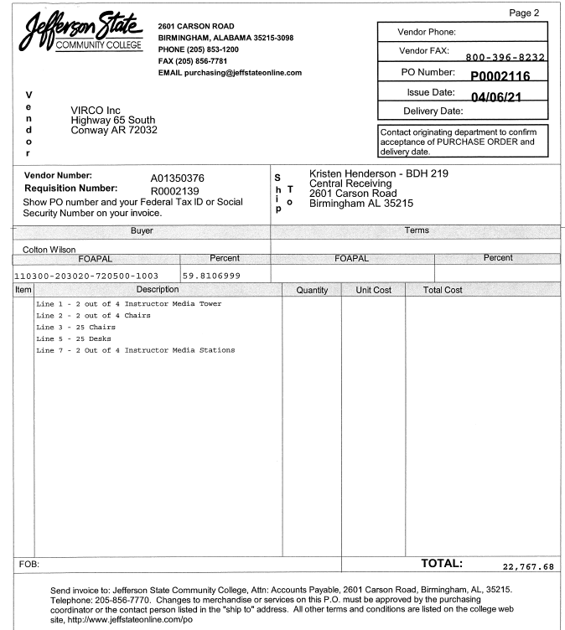

Photos of Products Purchased.
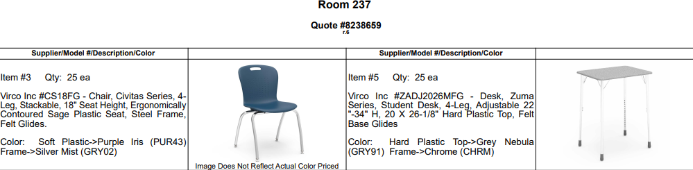

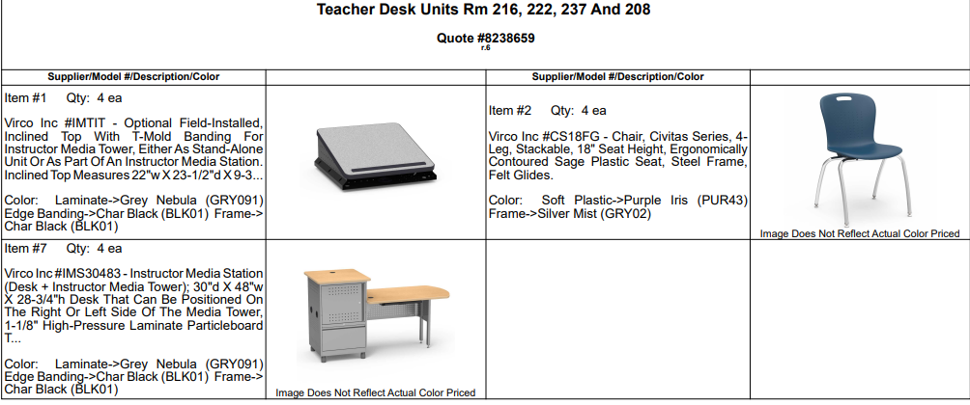

Concept Drawings of Common Area Furniture
