 |  |  | Goal Progress Report
Program: | Liberal Arts (Jefferson Campus) | Report period: |  | AY 2020-2021

Goals | Request & Justification/Resources | Goal Progress | Strategies Implemented & Follow-up
Goal 1: Maintain an informed and professional faculty to preserve the ability to offer courses to help students meet their educational and transfer goals. | - Provide support for professional development opportunities (on campus, virtual, in-state, and national).  - Staff courses with qualified instructors | - The college provided opportunities for professional development through OLC and QM online workshops. Faculty members used IAP funds to complete other activities. Due to the pandemic, most activities were virtual and at significantly reduced cost.  - The department was able to meet our needs with a combination of existing full-time and part-time instructors. Evaluations of full and part time faculty are conducted annually to determine instructor effectiveness. No new full-time instructors were required. We continue to review applications for additional part-time instructors as needed. | - The Department will continue to encourage peer training among faculty to develop technological skills to enhance instruction, as well as seek additional opportunities for professional development. Faculty will be encouraged to attend local, in-state, virtual, and out of state conferences. Funding will be requested for these opportunities. Faculty will also be encouraged to submit proposals for presenting at conferences, as well as leading in-house professional development meetings on campus. Another important part of our budget is the additional $2000.00 requested to support faculty attendance at conferences and professional development opportunities beyond the capabilities of the IAP funds. Instructors will be asked to utilize IAP funds before requesting support. Requests will be supported on a first come, first served basis until the budget is exhausted.  Faculty are also greatly appreciative of the continued support of the administration through IAP funds.  - Because there are some areas where part time faculty able to teach day classes are hard to find, we are sometimes limited at Jefferson in the number of courses we can offer. We continue to search for qualified instructors and will respectfully request permission to hire new full-time instructors as enrollment warrants.
Goal 2: Provide academic, developmental, and support services to assist students in achieving their academic goals, as well as fostering intellectual inquiry and creative growth. | - Support student organizations and programs to foster intellectual inquiry and creative growth.  - Purchase sanitation supplies (hand sanitizer dispensers, refill sanitizer packs, wipes) for cleaning classrooms. | - No organizations (Choir, Art and Animation Guild) requested financial support during the year of being virtual.  - Maintenance provided the supplies for sanitation and cleaning; therefore, no department funds were utilized to fulfill this goal. | - The Liberal Arts Department will continue to request funds each year to support student organizations and events relating to Liberal Arts.  - This goal will not be included in the next strategic plan or budget.
Goal 3: Maintain classroom and office equipment and supplies to enhance the quality of instruction and improve student learning. | - Replace student desks in BDH 208 with new student desks and chairs.  - Replace the instructor desks in BDH 222 and 237 with a new instructor table/media station/lectern combination unit.  - Add room darkening shades to classroom windows in BDH 216, and CH 300 and 301.  - Create an Emergency Replacement Fund for faculty technology (office computers and laptops) that fail unexpectedly.  - Complete the Student Common Area on the second floor of Bethune DeRamus Hall.  - Purchase a microwave oven stand or cart for student use to be housed in BDH. A cabinet is listed for purchase in the Liberal Arts Strategic Plan.  - Purchase Display Frames for the Art Department to display student art.  - Support the Art Department through the renewal of the ACME Network Yearly animation fee and the Adobe Animate Suite CS20 license. | - This goal was achieved. Forty-five student desks and 47 chairs (45 student + 2 instructor chairs) were purchased to replace the old desks in BDH 208.  - This goal was achieved. Both BDH 208 and 216 classrooms received an upgraded instructor desk set up consisting of a workspace, media tower with locking storage, and a lectern top.  - This goal was not achieved. The request was approved, but when inquiry was made, the department was informed the college had reached its allotment for this vendor.  - In AY 2020-2021, we did not need to access these funds.  - This proposal was submitted in 2019; however, no action has been taken to bring this to fruition.  - This goal was not achieved due to courses being offered mostly online during AY 2020-2021.  - This goal was not achieved. There were no students on campus to observe the artwork, and all student art was submitted online.  - This goal was achieved. | - In AY 2021-2022, the department will seek to replace the student desks in BDH 210 with the same desk and chair set up to match those chosen for BDH 208 and 216. This will continue the updating of the student furniture on the second floor of BDH, leaving only two rooms to outfit in the next two years.  - The department will submit a request to replace the instructor desk set up in BDH 220 to match those in BDH 222 and 237.  - The department will resubmit this request and attempt to purchase earlier in the budget year.  - The department will continue to request approval to replace failing instructor computers on an as needed basis. This request will be made separate from the regular replacement schedule provided by IT.  - The department believes a student area is necessary and needed by our students. BDH houses students in both Communications and Liberal Arts, and we teach courses taken by almost every TSGS student. The requested items include seating, study space, and charging capabilities for phones and laptops. The department will resubmit this proposal in the next strategic plan.  - Prior to the move to online instruction due to COVID, the only existing food option on campus was the Fitzgerald Deli. The Deli closed and will not reopen, leaving students with no options for meals other than vending machines while on campus. In addition, the Jefferson Campus is in a food desert with very few options available to students. The department wants to provide a place for students to heat food they may bring from home to eat while on campus. This request will be resubmitted.  - These frames will be a nice addition to the Art Department. They are structured to easily change artwork as new work is submitted. This request will be resubmitted.  - In order to build the animation courses, the department must keep technology and software licenses up-to-date and in alignment with industry standards. This request will continue to be submitted each year.
Submission date: August 24, 2021 |  | Submitted by: Liberal Arts Department, Jefferson Campus

P.O. for Replacement Student Chairs, Desks, and Instructor Desk Setup in Classrooms
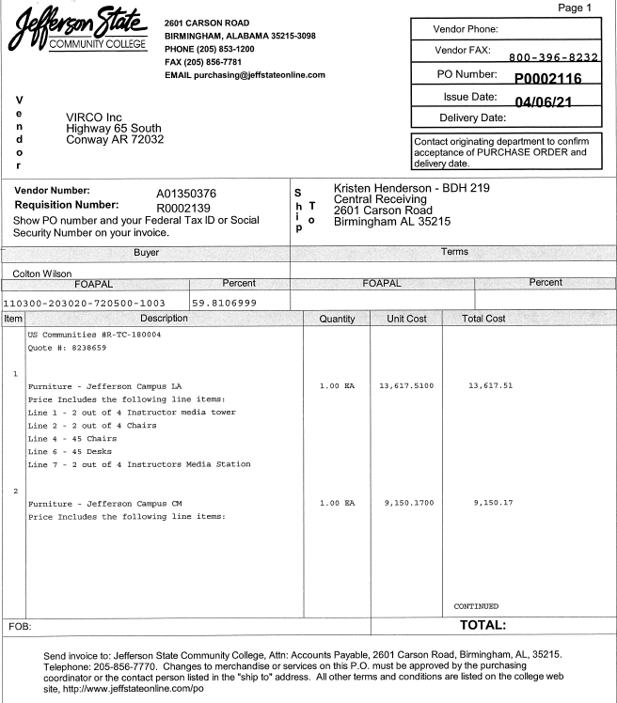

Photos of Products Purchased.
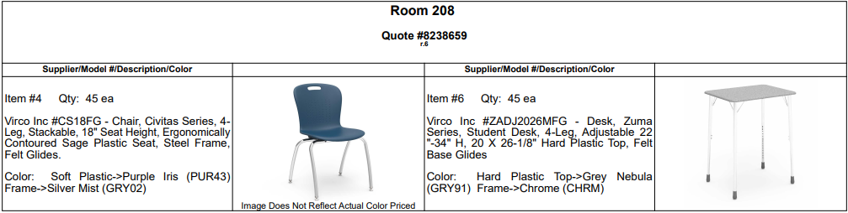

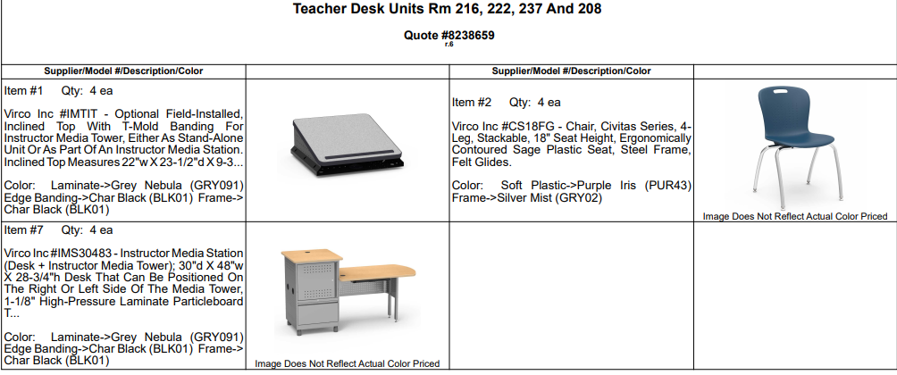

Concept Drawings of Common Area Furniture
