Unit Strategic Plan

2021-2023

Name of Program/Department: Communications – Jefferson Campus

Mission Statement (for the program or department):
The mission of the Communications Department is to develop in students a desire for excellence in scholarship, an ability to communicate effectively and an appreciation for the humanities. The department endorses the college’s Mission Statement and strives to uphold its commitment to learning.
The Communications Department strives to:
- Provide quality instruction in developmental and transferable courses through emphasis on continued training and professional development for faculty.
- Prepare students to continue their education at four-year institutions or to enter the workforce.
- Offer courses that allow students to develop communication skills and knowledge for personal enrichment or for job advancement

Summary of Access, Productivity and Effectiveness
The department offers English and speech courses that support the general education core. Most of the courses meet Area II requirements for the Alabama General Studies Committee/STARS Guide. Other courses are approved for Area V. Analysis of data from the Student Profile Data Report by CIP Code provided by IE shows that a diverse student population with respect to race/ethnicity, gender, and age is enrolled in courses offered by the department. The success of the Communications department is not best measured through the number of majors it produces. Very few students at Jefferson State Community College major in English or Speech. However, nearly every major, transfer program, and certificate program offered by the college requires a course or courses in English and/or speech. Therefore, the department reaches and serves almost every student on campus. The department has been successful in meeting the demands for course offering. Retention and success rates are consistent with that of the general college community, yet the completion rate for majors within the department remains low. This low completion rate occurs because students majoring in English or communication fields typically transfer to four-year institutions instead of graduating from Jefferson State. Advisors continue to encourage students to follow university parallel degree plans to earn AS degrees and complete reverse transfers as well. It should be noted that the department serves a large transient, accelerated program, and dual enrollment population.

Annual Credit Trend by Department
  - Jefferson Campus (incl. Online with Instructors assigned by the Jefferson Campus)
Department | 2018-2019 |  | 2019-2020 |  | 2020-2021
 | Total  Registrations | Credit  Hour  Production | Total  Registrations | Credit  Hour  Production | Total  Registrations | Credit  Hour  Production
ENG | 1618 | 4808 | 1455 | 4235 | 1522 | 4442
ENR | 63 | 252 | 81 | 324 | 35 | 140
SPH | 450 | 1350 | 338 | 1014 | 290 | 870
Total | 2,284 | 6869 | 1874 | 5816 | 1776 | 5452
  - Reflections and Implications:
The Jefferson Campus experienced a 20.63% decrease in Enrollment since AY 2018-2029: ENG (-7.6%), ENR (-44%), and SPH (-36%). ENR 098 actually saw an increase of almost 29% in 2019-2020, but the drop in enrollment in 2020-2021 was great. This drop could be a result of fewer students needing this developmental course. Students who qualify for the corequisite ENG 101 with ENG 099 but cannot schedule the course pair end up taking ENR 098. By the 2020-2021 year, the department offered more sections of the corequisite ENG 099 course, thus eliminating the need for some of the sections of ENR 098. It should also be noted that beginning in summer 2020, the college moved almost all courses online due to the COVID pandemic. The department chairs felt that students in developmental courses would benefit from a face-to-face course, and no sections were offered on campus until the Fall of 2020. Another issue with scheduling stemming from the move online was that in addition to full-time faculty, department chairs assigned online courses to part-time instructors who had previous experience teaching online sections. For this reason, the department had to offer fewer total courses.

Internal Conditions:

Technology
Keeping computers and other technology for faculty and classrooms current is an ongoing need. The department, upon consultation with IT, sets a four to five-year rotation plan for upkeep of equipment. All but one of the eight Communications classrooms in BDH are equipped with a computer, a projector, and a screen. All rooms with technology had equipment replaced and updated as of the 2014-2015 academic year. The department continues to monitor these rooms with IT and request updates or upgrades as equipment ages, becomes obsolete, or wears out.
All Communications instructors utilize computers in their offices for online instruction and preparation of instructional materials, creation of exams, record keeping, communication, etc. Some instructors utilize a dual monitor setup. Most instructor computers were upgraded in 2017-2018 year; additional computers or docking stations were replaced due to failure in the 2019-2020 academic year. Computers will be replaced as needed, or as the computers age out of usefulness and warranty. Laptops do require replacement sooner than desktops, but since all Communications instructors teach online courses, laptops are necessary. All instructors utilize VOIP phones.
The Division office in 219 has three computers (2 desktop/1 laptop with docking station). The office manager’s computer was purchased in the 2019-2020 year; the chair’s laptop was replaced in the 2019-2020 year. The other computer in the office was purchased in the 2014-2015 year. Both the office manager and the chair utilize a dual monitor setup. There are two printers in BDH 219: a large, networked copier/scanner/printer and a color laser printer. A desktop scanner, a small printer in BDH 209, and a Scantron grading machine are also available for faculty use. Both the chair and the office manager have VoIP telephones.
In the Part Time Office in 209, there are two computers that are shared with Liberal Arts Part Time instructors.
  - Summary Table: Age of Faculty Office Computers
OFFICE |  | COMPUTER
BDH 205 |  | 2018-2019
BDH 209 (PT) |  | 2014-2015
BDH 212 |  | 2016-2017
BDH 214 |  | 2019-2020
BDH 215 |  | 2016-2017
BDH 219  (DIV. OFFICE) | CHAIR | 2019-2020
 | OFFICE MGR | 2020-2021
 | OFFICE | 2014-2015
BDH 221 |  | 2016-2017

Budget
The budget for classroom and office supplies is sufficient and genuinely appreciated by the department faculty and staff.

Staffing
Starting with the 2021-2022 academic year, the Communications Department will have six full-time faculty (5 English and 1 Speech). In 2020, the department replaced the English instructor who had transferred to the Pell City Campus and another who had retired with two new full-time English instructors. The number of part-time faculty members decreased in 2020-2021 due to the move to all online courses as a result of the COVID pandemic. Starting in the fall of 2021, we are currently utilizing three part-time instructors teaching a combination of on campus and online courses, and two additional part-time instructors as tutors in the in-person and virtual writing lab. The department continues to monitor enrollment and course offerings to determine if additional sections and personnel are needed in English. In Speech, we have one full-time speech instructor. One of the new English instructors is also qualified to teach speech and has been teaching 1-2 speech courses since Spring of 2021. As of this writing, there are no planned retirements in the department. There is also one full-time Office Manager for the combined Communications and Liberal Arts Division. There are currently two work-study students to assist the department.
  - Percentage of Full-Time Faculty - Jefferson Campus
Department | 2018-2019 |  | 2019-2020 |  | 2020-2021
 | Total  Registrations | Full Time Faculty Percentage | Total  Registrations | Full Time Faculty Percentage | Total  Registrations | Full Time Faculty Percentage
ENG | 1618 | 68.9% | 1455 | 77% | 1522 | 86%
ENR | 63 | 69.8% | 81 | 55% | 35 | 100%
SPH | 450 | 94.7% | 338 | 100% | 290 | 100%

  - Credit Hour Production for AY 2019-2020 – Jefferson Campus
Department | Full Time |  |  |  | Part Time |  |  |  | Total
 | Sections | Enrolled | CHP | CHP% | Sections | Enrolled | CHP | CHP% | Sections | CHP
ENG | 49 | 1120 | 3165 | 77% | 16 | 314 | 942 | 23% | 65 | 4107
ENR | 3 | 35 | 140 | 55% | 2 | 29 | 116 | 45% | 5 | 256
SPH | 16 | 338 | 1014 | 100% | 0 | 0 | 0 | 0 | 16 | 1014

  - Credit Hour Production for AY 2020-2021 – Jefferson Campus
Department | Full Time |  |  |  | Part Time |  |  |  | Total
 | Sections | Enrolled | CHP | CHP% | Sections | Enrolled | CHP | CHP% | Sections | CHP
ENG | 55 | 1261 | 3659 | 86% | 12 | 194 | 582 | 14% | 67 | 4241
ENR | 4 | 35 | 140 | 100% | 0 | 0 | 0 | 0 | 4 | 140
SPH | 14 | 290 | 870 | 100% | 0 | 0 | 0 | 0 | 14 | 870

Resources
Faculty members are grateful to the college for providing funding to support professional development opportunities. Faculty members are encouraged to attend and present at conferences, upgrade their computer skills, and complete studies that help them to remain relevant in their fields. The department respectfully requests that this funding continue.

Enrollment
Enrollment numbers for the Communications Department at the Jefferson Campus are skewed due to the move to mostly online courses in the summer of 2020. The distribution of enrollment in traditional and online courses during fall and spring of 2019-2020 was typical, including offering traditional and online sections of the certain courses (ENG 101, ENG 102, ENG 251, and SPH 106). Courses such as ENG 099, ENR 098, and SPH 107 were offered mainly in the traditional format. Courses such as ENG 252, ENG 261 and ENG 262 are occasionally offered on campus. Unfortunately, enrollment for the traditional sections of these courses is typically low at this campus, but enrollment for online sections stays steady. Beginning in Fall 2020, after the retirement of the instructor who typically taught ENG 252 and 262 online, the ENG 261 and ENG 262 courses were taught by instructors from other campuses during the fall and spring. Also, in spite of most courses being online in 2020-2021, the department offered on campus sections of the developmental courses for students who still wanted a face-to-face course.
  - Enrollment per Course for 2020-2021 Academic Year – Jefferson Campus
2019-2020 |  |  |  |  |  |  |  |  |  |  |  | 2020-2021
Course | Traditional |  |  |  |  |  | Online |  |  |  |  | *Traditional |  |  |  |  |  | *Online
 | F |  | SP | *SU | Total |  | F | SP | *SU | Total |  | F |  | SP | SU |  | Total | F | SP | SU | Total
ENG 099 |  | 34 | 24 | 0 | 58 | 0 |  | 0 | 7 |  | 7 | 18 | 16 |  |  | 7 | 41 | 10 | 11 | 0 | 21
ENG 101 |  | 224 | 135 | 0 | 359 | 60 |  | 44 | 51 |  | 155 | 0 | 0 |  |  | 0 | 0 | 324 | 180 | 99 | 603
ENG 102 |  | 71 | 82 | 0 | 153 | 82 |  | 90 | 69 |  | 241 | 0 | 0 |  |  | 0 | 0 | 183 | 306 | 79 | 568
ENG 251 |  | 32 | 22 | 0 | 55 | 61 |  | 64 | 57 |  | 182 | 0 | 0 |  |  | 0 | 0 | 65 | 67 | 34 | 166
ENG 252 |  | 0 | 10 | 0 | 10 | 33 |  | 30 | 33 |  | 96 | 0 | 0 |  |  | 0 | 0 | 60 | 31 | 30 | 121
ENG 261 |  | 7 | 0 | 0 | 7 | 19 |  | 28 | 35 |  | 82 | 0 | 0 |  |  | 0 | 0 | 0 | 0 | 34 | 34
ENG 262 |  | 0 | 0 | 0 | 0 | 12 |  | 19 | 20 |  | 51 | 0 | 0 |  |  | 0 | 0 | 0 | 0 | 0 | 0
ENR 098 |  | 41 | 27 | 0 | 68 | 13 |  | 0 | 0 |  | 13 | 19 | 16 |  |  | 0 | 35 | 0 | 0 | 0 | 0
SPH 106 |  | 68 | 81 | 0 | 149 | 45 |  | 0 | 62 |  | 107 | 0 | 0 |  |  | 0 | 0 | 65 | 65 | 19 | 149
SPH 107 |  | 43 | 43 | 0 | 86 | 0 |  | 0 | 20 |  | 20 | 0 | 0 |  |  | 0 | 0 | 41 | 64 | 18 | 123

Facilities
The Communications Department offers classes in Bethune-DeRamus Hall. Currently the department uses eight classrooms for instruction in English and speech (116, 118, 121, 129, 139, 220, 222, and 237). Rooms 114 and 129 are overflow rooms lacking technology and upgrades. The Writing Center has moved to the Allen Library where the new Learning Success Center is located. In 2020, the department began replacing the student desks in the classrooms. BDH 222 was the first room upgraded with 25 new student desks and separate chairs. In 2021, BDH 237 was upgraded with 25 new student desks and chairs, and both BDH 222 and 237 received new instructor tables with an attached media station and lectern top. The plan is to replace student and instructor desks in BDH 220 in AY 2021-2022, and then seek to replace furniture in one classroom each year until all rooms have been updated.
Faculty has adequate office space in BDH, utilizing five offices (205, 212, 214, 215, and 221). The remaining offices (207, 223, 225, and 227) are currently being used for department storage or by student organizations. The bookroom is housed in 217. Unused space in 211 was converted into a make-up testing room, which is available for students to use for study purposes when it is not being used for testing. The Part-Time Instructor workroom in 209 is shared with Liberal Arts. This space is large and open, providing a place for Part-Time instructor mailboxes, a computer, worktables, instructor file storage, department storage, and a refrigerator and microwave (although these appliances are ancient). This area also provides VOIP telephones for part-time instructors to use.
Classroom and office space is adequate. All faculty offices have been upgraded with office ensembles that provide a more professional office space.
The Division office in BDH 219 houses the Chair, Office Manager, full-time faculty mailroom, storage and secure file areas, a small workroom with printer/copier/scanner, and the work study student desk. The office suite also includes space for secure storage, a waiting area, a copy/scantron area, and a break room.

Equipment
In addition to the technologic equipment previously mentioned, the department also has DVD/VCR combos in some classrooms. These units are not supported by newer projectors. In addition, we have three portable TV sets that can be moved from room to room, although these are rarely utilized.

External Conditions
The division’s accreditation comes through the college’s general accreditation with the Southern Association of Colleges and Schools—SACSCOC. The college completed a three-year program review in 2019, as well as a three-year assessment cycle. The department has made appropriate adjustments based upon the data.
The division is impacted by ACCS Post-Secondary policy changes when applicable. Changes have been made in the area of Developmental Education. ENG 093, ENR 094, and RDG 085 have been replaced with a comprehensive ENR 098 course for developmental needs. ACCS also added ENG 099 as a corequisite course for students who can be successful in ENG 101 with a little more support than the typical 101 students, but who do not necessarily need to take the ENR 098. The AGSC updated the Course Outcomes for all English and Speech courses beginning in Spring 2019. These updates were fully implemented in fall 2021. The department uses the STARS articulation guide to inform its curriculum and course offerings.

2019-2020 Accomplishments:
- The Red Mountain Reading Series explored the theme “Candid Encounters” and focused on authors discussing topics that can sometimes cause discomfort. The first two events were held in person; they were readings by memoirist Heather Wyatt and poets Ashley M. Jones and Tina Mozelle Braziel. Attendance at these in-person events was approximately 85.
- The Red Mountain Reading Series’ final presentation was moved online and held through Zoom. It was a talk by screenwriter and director Daniel Scheinert, hosted in partnership with Sidewalk Film Center + Cinema. This drew an audience of 40, with attendees from Birmingham as well as from Mexico and Sweden.
- The Red Mountain Reading Series received a grant from the Alabama Humanities Foundation.
- Wingspan was reformatted to dimensions of 8.5” by 11.5” to present a more professional appearance. The magazine was 121 pages and published 92 works of visual and literary art by 57 members of the Jeff State Community.
- Pioneer Con featured 8 academic sessions, two rounds of a Dungeons & Dragons campaign, and a live trivia game. The event also opened a popular drop-in game room with a video game console, card games, and board games. The keynote speaker was editor and weird fiction writer Jon Padgett, author of The Secret of Ventriloquism. Total attendance was around 250.
- The department hosted the annual UWRITE conference for full-time and part-time faculty and dual enrollment instructors.
- Faculty members attended various workshops provided by the College, including ADA Compliance, Pioneer Con, Black History Program, and Constitution Day.
- Faculty members attended the Birmingham Institute for Writing (UAB).
- Other conferences attended by faculty include the ACCSHRMA Diversity Conference, the ACETA spring conference, and the LGBTQ Allyship Conference.
- One instructor published a book Call My Name, A Chapbook of Poems, The Poetry Box 2019. This instructor also had the following essays published: “I didn’t kill my husband today” in The Syndrome Mag and “Her?!” in The Doctor T. J. Eckleburg Review.
- One department faculty member completed the ACCS Instructional Leadership Academy (ILA).
- One student from an English course presented a paper at the ACETA conference at the University of North Alabama.
- The Communications Department continued to support the Red Mountain Reading Series, Wingspan, The Writer’s Round Table, the Concert and Lecture Series, Sigma Kappa Delta, and Sigma Chi Eta.
- One faculty member participated in a cross-curricular professional development trip to Salem, Massachusetts, to study literary and historical sites to prepare for participation in the upcoming JSCC Digital Museum.
- Student desks in BDH 222 were replaced with updated desks with separate chairs.
- Three faculty computers were replaced.
- One instructor piloted new technology from McGraw Hill in composition courses.
- One instructor began a PhD program with Regents University.

2020-2021 Accomplishments:
- The Red Mountain Reading Series hosted a fully virtual reading series that explored the theme “Crossing Genres” and focused on writers who have been successful in more than one form of literary expression. Presenters included poet and educator William Miller; poet, humorist, and professor Juliana Gray; and poet, playwright, and fiction writer Angela Jackson-Brown. Total attendance for all sessions was approximately 130.
- The Red Mountain Reading Series hosted a table read of Angela Jackson-Brown’s unpublished play Trailer Park Love Stories. The table read was directed by Drama Instructor Lesley Warren, and students and faculty performed the roles.
- Wingspan published 94 works of visual and written art by 52 students, faculty, and members of the community. The magazine was 114 pages in length. Those published included the winners of the inaugural Pioneer Con writing contest.
- Wingspan’s submission process moved online, to a form hosted by Jeff State Libraries.
- Pioneer Con was held virtually, through a mix of 6 live Zoom presentations and 4 pre-recorded videos. The keynote speaker was T. K. Thorne, author of House of Rose. Attendance at each session was 12-15, but the website received over 300 unique site visits.
- Pioneer Con also held its first writing contest, with prizes offered in three categories: Essay on Core Text, Essay on Visual Media, and Short Fiction.
- One instructor from the department had students participate in the JSCC Digital Museum on the theme of Pirates.
- One instructor completed the Instructional Leadership Academy (ILA), including a complete course redesign.
- All instructors participated in the Online Learning Consortium Workshops relating to Engagement, ADA, and Feedback.
- Several instructors have completed the Applying the Quality Matters Rubric online course.
- One instructor wrote and executive produced the short film “Garden of the Gods” which is being premiered at film festivals, including the local Sidewalk Film Festival. This film received recognition as “Best Horror” at the Georgia Shorts Film Festival and was a finalist for “Best Dark Drama” at the Austin After Dark Film Festival in Austin, Texas.
- One faculty member serves as 2nd Vice President for the Alabama Writers Cooperative.
- One faculty member served as a screenwriting judge for Miami International Science Fiction Film Festival.
- One instructor published the essay “A Goss, Happy Proposal” in High Noon.
- One instructor completed a second MA degree and began a PhD program in Communications at the University of Alabama.
- One instructor was nominated for the Outstanding Faculty Award.
- One instructor was elected Secretary of the Faculty Senate.
- The department purchased 25 new student desks and chairs for BDH 237 and two instructor tables with media stations for BDH 237 and BDH 222.

Unit Goals for 2021-2022

Goal 1: Maintain an informed and professional faculty to preserve the ability to offer courses to help students meet their educational and transfer goals.
Objectives, Methods of Assessment, & Funding Requests:

OBJ. 1: Provide support for professional development.
- Provide professional development activities on campus through roundtable discussions, guest speaker presentations, and workshops for faculty to maintain knowledge of current trends and technology in their fields.
- Encourage faculty to attend local, in-state, and out-of-state conferences.
- Encourage faculty to submit proposals to present at local, in-state, and out-of-state conferences.

Method of Assessment for Objective 1:
- Provide workshops where faculty who have specialized knowledge in technology provide training to other faculty to enhance instruction (Office 365 for Instructors, Blackboard tutorials, Presentation Platforms, Creating Instructional Videos for Online Classes, etc.)
- Support the UWRITE committee in planning and hosting the UWRITE Conference in June 2022
- Maintain institutional memberships or subscriptions with professional organizations: ACETA.
- Survey faculty (informally) to determine areas of interest to plan the on-campus sessions for each semester. Following each session, participants will evaluate the session.
- Review faculty Individual Action Plans for meaningful professional development opportunities, track the number of grants and requests submitted, and track the number of faculty attending conferences.
- Track the number of faculty submitting proposals for presentations at conferences.
- Ask faculty who have attended conferences to share their experiences with faculty.

OBJ. 2: Enhance the effectiveness of English and Speech courses by encouraging instructors to collaborate on best practices, methods, and assignments.

Method of Assessment for Objective 2:
- Schedule at least one meeting each semester to encourage sharing ideas and collaboration.
- With the help of faculty, set up a Teams Group where instructors can quickly share information and ideas.

OBJ. 3: Continue to staff courses with qualified instructors.

Method of Assessment for Objective 3:
- Evaluate enrollment numbers to determine the need for hiring an additional English or speech instructor. If the enrollment numbers warrant, the necessary requests for personnel will be submitted to the administration for approval.
- Review applications and conduct interviews for additional part-time instructors and writing lab tutors as needed.

2021-2022 Total Funds Requested for Goal #1: $115, 500. 00
Goal #1: Maintain an informed and professional faculty to preserve the ability to offer courses to help students meet their educational and transfer goals.

OBJ. 1: Provide support for professional development.
 | Breakdown of Requested Amounts | Description of how funds will be used to accomplish objective.
 | $500.00 | Support the UWRITE committee costs, including an honorarium for keynote speaker. (Shelby will request the same amount).
 | $1000.00 | Purchase licenses/registration for online seminars as well as to pay honorariums for workshops provided by guest lecturers/professors. (Shelby will request the same amount).
 | $1000.00 | Maintain institutional memberships or subscriptions with professional organizations, such as The Teaching Professor, Teaching English in the Two-Year College, and ACETA
 | $2000.00 | Support conference attendance/professional development opportunities for faculty. Instructors will be asked to utilize IAP funds before requesting support. Requests will be supported on a first come, first served basis until the budget is exhausted.
 | $1000.00 | Purchase of professional development materials

OBJ. 2: Enhance the effectiveness of English and Speech courses by encouraging instructors to collaborate on best practices, methods, and assignments.
 | NONE | No funding requested for OBJ. 2

OBJ. 3: Continue to staff courses with qualified instructors.
 | $55,000.00 | Hire an English instructor.
 | $55,000.00 | Hire an additional Speech instructor if necessary.

Goal 2: Provide academic, developmental, and support services to assist students in achieving their academic goals, as well as fostering intellectual inquiry and creative growth.

Objectives, Methods of Assessment, & Funding Requests:

OBJ. 1: Maintain and expand the Writing Center on campus where students may get live, one-on-one help with written compositions from experienced tutors in person and online.

Method of Assessment for Objective. 1:
- Continue working with the Library on the use of the LibCal software for the online tutoring and paper review.
- Create more effective online logging system to track Writing Lab usage by students
- Monitor the number of students who seek the services of the Writing Lab
- Pursue avenues for expansion and advertising to increase student awareness of the benefits of using the Writing Lab.

OBJ. 2: Support student organizations (Sigma Kappa Delta, Sigma Chi Eta, and the Speech Team) with financial assistance for attendance at national conventions or other financial support.

Method of Assessment for Objective. 2:
- Monitor requests by organizations for attendance at their national conventions or other support, as well as the number of student members and activities completed.

OBJ. 3: Continue financial support for Pioneer Con, Red Mountain Reading Series, Wingspan, The Writer’s Roundtable, and the Concert and Lecture Series.

Method of Assessment for Objective. 3:
- Monitor offerings and attendance at each of the speaking events.
- Monitor submissions and distribution of Wingspan

OBJ. 4: Offer a welcoming environment for students in the department equipped with seating and study space, as well as attractive informational bulletin boards and books to read.
Method of Assessment for Objective. 4:
- Follow up on previously submitted proposal and resubmit with revisions if necessary.
OBJ. 5: Continue to review Student Learning Outcomes and assessments for each course.

Method of Assessment for Objective 5:
- Study data derived from assessment to determine how to best modify instruction to encourage mastery of each SLO.
- Implement changes to SLOs and assessment
- Conduct faculty reviews of SLOs for each course to determine the need for changes in the next three-year cycle.
- Revise course objectives/competency documents as needed.

OBJ. 6: Create a Course Information Exhibit to provide specific course information (beyond the catalog) to increase enrollment in on-campus courses.

Method of Assessment for Objective 6:
- Create informational pamphlets on each course offered in the department.
- Set up a wall-mounted display center in BDH with information accessible to students.
- Prepare exhibits and manned- tables during Registration and Advising times to engage students.
OBJ. 7: Support the College Scholars Team by purchasing a new buzzer system.

Method of Assessment for Objective 7:
- Request the purchase of the new buzzer system to replace the current outdated system.

2021-2022 Total Funds Requested for Goal #2: $9,350.00

Goal #2: Provide academic, developmental, and support services to assist students in achieving their academic goals, as well as fostering intellectual inquiry and creative growth.

OBJ. 1: Maintain and expand the Writing Center on campus where students may get live, one-on-one help with written compositions from experienced tutors.
 | Breakdown of Requested Amounts | Description of how funds will be used to accomplish objective.
 | $500 | Supplies & Books for the Writing Lab

OBJ. 2: Support student organizations (Sigma Kappa Delta, Sigma Chi Eta, and the Speech Team) with financial assistance for attendance at national conventions or other support.
 | $1000.00 | Support Sigma Kappa Delta’s attendance at their convention. (Shelby will also be requesting this amount.)
 | $1000.00 | Support Sigma Chi Eta’s attendance at their convention. (Shelby will also be requesting this amount.)
 | $1000.00 | Support the Speech Team’s attendance at their convention. (Shelby will also be requesting this amount; Tournament funding is provided by the foundation.)

OBJ. 3: Continue financial support for Pioneer Con, Red Mountain Reading Series, Wingspan, The Writer’s Roundtable, and the Concert and Lecture Series.
 | $500.00 | Support for Pioneer Con expenses not covered by SKD. (Shelby will also be requesting this amount.)
 | $1000.00 | Support Red Mountain Reading Series. (Shelby will also be requesting this amount.)
 | $1000.00 | Support printing and publication expenses for Wingspan. (Shelby will also be requesting this amount.)
 | $250.00 | Support Writer’s Roundtable expenses for printing, advertising, and refreshments. (Shelby will also be requesting this amount.)
 | $500.00 | Support the Concert and Lecture Series (Lecture portion). (Shelby will also be requesting this amount.)

OBJ. 4: Offer a welcoming environment for students in the department equipped with seating and study space, as well as attractive informational bulletin boards and books to read.
 | $1000.00 | Furnishings for the Student area on the second floor of BDH. Please see full proposal. (This budget item is in addition to the $3000.00 provided by the Leadership Academy’s project and the amount requested through the Liberal Arts budget.)
 | $250.00 | Microwave oven for student use.

OBJ. 5: Continue to review Student Learning Outcomes and assessments for each course.
 | NONE | No funding requested for OBJ. 5

OBJ. 6: Create a Course Information Exhibit to provide specific course information (beyond the catalog) to increase enrollment in on-campus courses.
 | $150.00 | Candy, snacks, etc. for table displays during on-campus events
 | $ 400.00 | Printing course pamphlets
 | $300.00 | Wall mounted 12-16 space pamphlet holder
OBJ. 7: Support the College Scholars Team by purchasing a new buzzer system.
 | $500.00 | Quik Pro Deluxe Buzzer System for College Scholars Team

Goal 3: Maintain classroom and office equipment and supplies to enhance the quality of instruction and improve student learning.

Objectives, Methods of Assessment, & Funding Requests:

OBJ. 1: Enhance student learning and the quality of instruction offered to students through using up-to-date, appropriate equipment, furniture, and technology in the classrooms.

Methods of Assessment for Objective 1:
- Submit requests to IT to replace classroom computers, projectors, and other equipment as needed to offer quality instruction and enhance student learning and maintain functionality and currency.
- Replace classroom furniture (i.e., student desks, lecterns, instructor desk area) in BDH 220 to create a more comfortable and modern classroom experience and an enhanced learning environment for students.
- Monitor the purchase, installation, and updating of classroom software and hardware to ensure currency.
- Survey faculty to determine the need for upgraded or new equipment, furniture, and technology for use in the classrooms.
- Offer training on campus for faculty relating to using technology to improve instruction, including the LMS system, document cameras, recording software, and textbook software.
- Process requisitions for equipment requested through the technology plan upon approval and on an as-needed basis.

OBJ. 2: Replace faculty and staff office computers, software, furniture, and other equipment as needed to ensure faculty continue to function as effective instructors.

Methods of Assessment for Objective 2:
- Survey faculty to determine needs.
- As classroom equipment fails or needs upgrading, report and request to be replaced to maintain functionality and currency.
- Process requisitions for equipment requested through the technology plan upon approval and on an as-needed basis.
- Submit requests to replace consumable supplies and furniture/equipment as needed to the administration for approval.

OBJ. 3: Encourage instructors to evaluate new technology and equipment by piloting projects in their courses.

Methods of Assessment for Objective 3:
- Survey faculty to identify those who wish to pilot new methods and technology. Faculty will submit a plan/proposal, and the budget will be planned accordingly for necessary purchases.

2021-2022 Total Funds Requested for Goal #3: $18,329.91

Goal #3: Maintain classroom and office equipment and supplies to enhance the quality of instruction and improve student learning.

OBJ. 1: Enhance student learning and the quality of instruction offered to students through using up-to-date, appropriate equipment, furniture, and technology in the classrooms.
 | Breakdown of Requested Amounts | Description of how funds will be used to accomplish objective.
 | $4,593.75 | Desk Zuma Series x 35 to replace student desks in BDH 220 (Virco) *Estimate based on April 2021 purchase.
 | $3,316.32 | Civitas Series chairs x 36 to replace student seating in BDH 220 (includes one chair for instructor seating per room) (Virco) *Estimate based on April 2021 purchase.
 | $1,514.03 | Instructor media station (media tower and peninsula desk) for BDH 220 (Virco) *Estimate based on April 2021 purchase.
 | $175.81 | Lectern top for media station in BDH 220. (Virco) *Estimate based on April 2021 purchase.
 | $ 1800.00 | Room darkening Shades (BDH 222 and 237)

OBJ. 2: Replace faculty and staff computers, software, furniture, and other equipment as needed to ensure faculty continue to function as effective instructors.
 | $5,000.00 | Emergency Fund for replacing faculty computers due to unexpected failures.
 | $500.00 | Desk Chairs for Instructor Office (BDH 215) & Office Manager
 | $50.00 | 1 Chair mat for Office Manager’s Office (BDH 219)
 | $200.00 | Computer monitor to replace second unusable monitor for office manager (current one is too dark to see; IT has been unable to fix)
 | $180.00 | X-Acto Heavy-Duty 15x15 Paper Trimmer for Department Use

OBJ. 3: Encourage instructors to evaluate new technology and equipment by piloting projects in their courses.
 | $1000.00 | Materials for classroom evaluation/pilots

Unit Goals for 2022-2023

Goal 1: Maintain an informed and professional faculty to preserve the ability to offer courses to help students meet their educational and transfer goals.
Objectives, Methods of Assessment, & Funding Requests:

OBJ. 1: Provide support for professional development.
- Provide professional development activities on campus through roundtable discussions, guest speaker presentations, and workshops for faculty to maintain knowledge of current trends and technology in their fields.
- Encourage faculty to attend local, in-state, and out-of-state conferences.
- Encourage faculty to submit proposals to present at local, in-state, and out-of-state conferences.

Method of Assessment for Objective 1:
- Provide workshops where faculty who have specialized knowledge in technology provide training to other faculty to enhance instruction (Office 365 for Instructors, Blackboard tutorials, Presentation Platforms, Creating Instructional Videos for Online Classes, etc.)
- Support the UWRITE committee in planning and hosting the UWRITE Conference in June 2023
- Maintain institutional memberships or subscriptions with professional organizations: ACETA.
- Survey faculty (informally) to determine areas of interest to plan the on-campus sessions for each semester. Following each session, participants will evaluate the session.
- Review faculty Individual Action Plans for meaningful professional development opportunities, track the number of grants and requests submitted, and track the number of faculty attending conferences.
- Track the number of faculty submitting proposals for presentations at conferences.
- Ask faculty who have attended conferences to share their experiences with faculty.

OBJ. 2: Enhance the effectiveness of English and Speech courses by encouraging instructors to collaborate on best practices, methods, and assignments.

Method of Assessment for Objective 2:
- Schedule at least one meeting each semester to encourage sharing ideas and collaboration.
- With the help of faculty, set up a Teams Group where instructors can quickly share information and ideas.

OBJ. 3: Continue to staff courses with qualified instructors.

Method of Assessment for Objective 3:
- Evaluate enrollment numbers to determine the need for hiring an additional English or speech instructor. If the enrollment numbers warrant, the necessary requests for personnel will be submitted to the administration for approval.
- Review applications and conduct interviews for additional part-time instructors and writing lab tutors as needed.

2022-2023 Total Funds Requested for Goal #1: $115,500.00
Goal #1: Maintain an informed and professional faculty to preserve the ability to offer courses to help students meet their educational and transfer goals.

OBJ. 1: Provide support for professional development.
 | Breakdown of Requested Amounts | Description of how funds will be used to accomplish objective.
 | $500.00 | Support the UWRITE committee costs, including an honorarium for keynote speaker. (Shelby will request the same amount).
 | $1000.00 | Purchase licenses/registration for online seminars as well as to pay honorariums for workshops provided by guest lecturers/professors. (Shelby will request the same amount).
 | $1000.00 | Maintain institutional memberships or subscriptions with professional organizations, such as The Teaching Professor, Teaching English in the Two-Year College, and ACETA
 | $2000.00 | Support conference attendance/professional development opportunities for faculty. Instructors will be asked to utilize IAP funds before requesting support. Requests will be supported on a first come, first served basis until the budget is exhausted.
 | $1000.00 | Purchase of professional development materials

OBJ. 2: Enhance the effectiveness of English and Speech courses by encouraging instructors to collaborate on best practices, methods, and assignments.
 | NONE | No funding requested for OBJ. 2

OBJ. 3: Continue to staff courses with qualified instructors.
 | $55,000.00 | Hire an additional English instructor if necessary.
 | $55,000.00 | Hire an additional Speech instructor if necessary.

Goal 2: Provide academic, developmental, and support services to assist students in achieving their academic goals, as well as fostering intellectual inquiry and creative growth.

Objectives, Methods of Assessment, & Funding Requests:

OBJ. 1: Maintain and expand the Writing Center on campus where students may get live, one-on-one help with written compositions from experienced tutors in person and online.

Method of Assessment for Objective. 1:
- Continue working with the Library on the use of the LibCal software for the online tutoring and paper review.
- Create more effective online logging system to track Writing Lab usage by students
- Monitor the number of students who seek the services of the Writing Lab
- Pursue avenues for expansion and advertising to increase student awareness of the benefits of using the Writing Lab.

OBJ. 2: Support student organizations (Sigma Kappa Delta, Sigma Chi Eta, and the Speech Team) with financial assistance for attendance at national conventions or other financial support.

Method of Assessment for Objective. 2:
- Monitor requests by organizations for attendance at their national conventions or other support, as well as the number of student members and activities completed.

OBJ. 3: Continue financial support for Pioneer Con, Red Mountain Reading Series, Wingspan, The Writer’s Roundtable, and the Concert and Lecture Series.

Method of Assessment for Objective. 3:
- Monitor offerings and attendance at each of the speaking events.
- Monitor submissions and distribution of Wingspan

OBJ. 4: Offer a welcoming environment for students in the department equipped with seating and study space, as well as attractive informational bulletin boards and books to read.
Method of Assessment for Objective. 4:
- Follow up on previously submitted proposal and resubmit with revisions if necessary.
OBJ. 5: Continue to review Student Learning Outcomes and assessments for each course.

Method of Assessment for Objective 5:
- Study data derived from assessment to determine how to best modify instruction to encourage mastery of each SLO.
- Implement changes to SLOs and assessment
- Conduct faculty reviews of SLOs for each course to determine the need for changes in the next three-year cycle.
- Revise course objectives/competency documents as needed.

OBJ. 6: Create a Course Information Exhibit to provide specific course information (beyond the catalog) to increase enrollment in on-campus courses.

Method of Assessment for Objective 6:
- Create informational pamphlets on each course offered in the department.
- Set up a wall-mounted display center in BDH with information accessible to students.
- Prepare exhibits and manned- tables during Registration and Advising times to engage students.

2022-2023 Total Funds Requested for Goal #2: $8,550.00

Goal #2: Provide academic, developmental, and support services to assist students in achieving their academic goals, as well as fostering intellectual inquiry and creative growth.

OBJ. 1: Maintain and expand the Writing Center on campus where students may get live, one-on-one help with written compositions from experienced tutors.
 | Breakdown of Requested Amounts | Description of how funds will be used to accomplish objective.
 | $500 | Supplies & Books for the Writing Lab

OBJ. 2: Support student organizations (Sigma Kappa Delta, Sigma Chi Eta, and the Speech Team) with financial assistance for attendance at national conventions or other support.
 | $1000.00 | Support Sigma Kappa Delta’s attendance at their convention. (Shelby will also be requesting this amount.)
 | $1000.00 | Support Sigma Chi Eta’s attendance at their convention. (Shelby will also be requesting this amount.)
 | $1000.00 | Support the Speech Team’s attendance at their convention. (Shelby will also be requesting this amount; Tournament funding is provided by the foundation.)

OBJ. 3: Continue financial support for Pioneer Con, Red Mountain Reading Series, Wingspan, The Writer’s Roundtable, and the Concert and Lecture Series.
 | $500.00 | Support for Pioneer Con expenses not covered by SKD. (Shelby will also be requesting this amount.)
 | $1000.00 | Support Red Mountain Reading Series. (Shelby will also be requesting this amount.)
 | $1000.00 | Support printing and publication expenses for Wingspan. (Shelby will also be requesting this amount.)
 | $250.00 | Support Writer’s Roundtable expenses for printing, advertising, and refreshments. (Shelby will also be requesting this amount.)
 | $500.00 | Support the Concert and Lecture Series (Lecture portion). (Shelby will also be requesting this amount.)

OBJ. 4: Offer a welcoming environment for students in the department equipped with seating and study space, as well as attractive informational bulletin boards and books to read.
 | $1000.00 | Furnishings for the Student area on the second floor of BDH. Please see full proposal. (This budget item is in addition to the $3000.00 provided by the Leadership Academy’s project and the amount requested through the Liberal Arts budget.)
 | $250.00 | Microwave oven for student use.

OBJ. 5: Continue to review Student Learning Outcomes and assessments for each course.
 | NONE | No funding requested for OBJ. 5

OBJ. 6: Create a Course Information Exhibit to provide specific course information (beyond the catalog) to increase enrollment in on-campus courses.
 | $150.00 | Candy, snacks, etc. for table displays during on-campus events
 | $ 400.00 | Printing course pamphlets

Goal 3: Maintain classroom and office equipment and supplies to enhance the quality of instruction and improve student learning.

Objectives, Methods of Assessment, & Funding Requests:

OBJ. 1: Enhance student learning and the quality of instruction offered to students through using up-to-date, appropriate equipment, furniture, and technology in the classrooms.

Methods of Assessment for Objective 1:
- Submit requests to IT to replace classroom computers, projectors, and other equipment as needed to offer quality instruction and enhance student learning and maintain functionality and currency.
- Replace classroom furniture (i.e., student desks, lecterns, instructor desk area) in BDH 220 to create a more comfortable and modern classroom experience and an enhanced learning environment for students.
- Monitor the purchase, installation, and updating of classroom software and hardware to ensure currency.
- Survey faculty to determine the need for upgraded or new equipment, furniture, and technology for use in the classrooms.
- Offer training on campus for faculty relating to using technology to improve instruction, including the LMS system, document cameras, recording software, and textbook software.
- Process requisitions for equipment requested through the technology plan upon approval and on an as-needed basis.

OBJ. 2: Replace faculty and staff office computers, software, furniture, and other equipment as needed to ensure faculty continue to function as effective instructors.

Methods of Assessment for Objective 2:
- Survey faculty to determine needs.
- As classroom equipment fails or needs upgrading, report and request to be replaced to maintain functionality and currency.
- Process requisitions for equipment requested through the technology plan upon approval and on an as-needed basis.
- Submit requests to replace consumable supplies and furniture/equipment as needed to the administration for approval.

OBJ. 3: Encourage instructors to evaluate new technology and equipment by piloting projects in their courses.

Methods of Assessment for Objective 3:
- Survey faculty to identify those who wish to pilot new methods and technology. Faculty will submit a plan/proposal, and the budget will be planned accordingly for necessary purchases.

2022-2023 Total Funds Requested for Goal #3: $21,167.21

Goal #3: Maintain classroom and office equipment and supplies to enhance the quality of instruction and improve student learning.

OBJ. 1: Enhance student learning and the quality of instruction offered to students through using up-to-date, appropriate equipment, furniture, and technology in the classrooms.
 | Breakdown of Requested Amounts | Description of how funds will be used to accomplish objective.
 | $3,281.25 | Desk Zuma Series x 25 to replace student desks in BDH 118 (Virco)
 | $2,395.12 | Civitas Series chairs x 26 to replace student seating in BDH 118 (includes one chair for instructor seating per room) (Virco)
 | $1,514.03 | Instructor media station (media tower and peninsula desk) for BDH 118 (Virco)
 | $176.81 | Lectern top for media station in BDH 118. (Virco)
 | $1,800.00 | Room darkening Shades (BDH 220 and 118)

OBJ. 2: Replace faculty and staff computers, software, furniture, and other equipment as needed to ensure faculty continue to function as effective instructors.
 | $6,000.00 | Faculty computers to replace aging and out of warranty machines: BDH 205, 212, 215)
 | $5,000.00 | Emergency Fund for replacing faculty computers due to unexpected failures.

OBJ. 3: Encourage instructors to evaluate new technology and equipment by piloting projects in their courses.
 | $1,000.00 | Materials for classroom evaluation/pilots

Student Common Area Proposal (originally submitted in November 2019)

BDH 2nd Floor Central Area

Rationale: Get the most for the money available and complete one entire space by combining the Mini-Student Area budget with the budget from Communications and Liberal Arts Strategic Plans.
Although the first floor of BDH serves as the gateway from the parking lot to the rest of the campus, the second floor is where the students congregate in this building. The floor houses eight Communications and Liberal Arts classrooms that serve nearly all students in Transfer and Career programs at the College. By combining the $3,000 allocated for the area with the $1,950 budgeted in the Communications and Liberal Arts 2019-2021 Strategic Plans for “creating a welcoming environment” and a course information center, we could completely outfit this space to provide our students with areas for seating, study, and device charging. The central area has two usable corners, an alcove by the large front windows, and some open wall space.

Alcove
The south-facing alcove is an ideal place for a bar height narrow table with linear seating for 4-5 students. Wiring could be extended along this wall to provide 3-4 outlets for device charging.
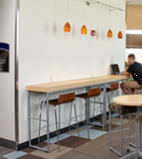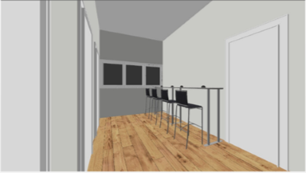
Concept Photo
3D Rendering: This seating area would be ideal for students to study, work on a laptop, or charge devices while they wait to meet with instructors or for a class to start.

The Global Swap Table 30”d x 96”w x 42”h and four Ki Strive stools would be perfect for this space.
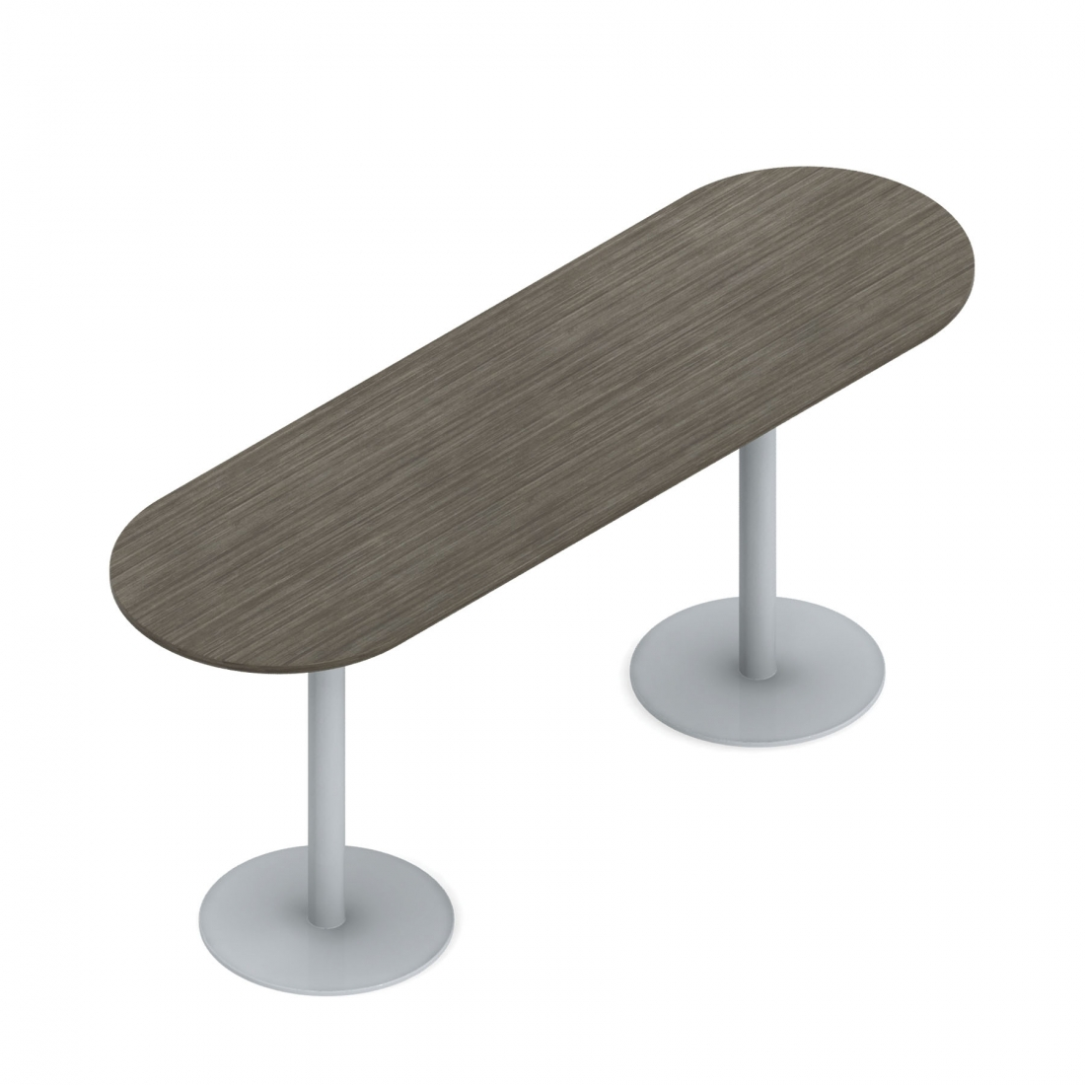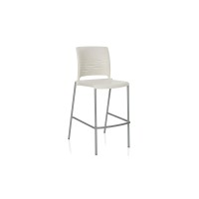

Central Area
The corner nook toward the left hallway (if facing the central windows) would be ideal for a table with four chairs. Since there would be bar-height seating in the alcove, this table would be regular table height to allow for wheelchair accessibility. Wiring for two outlets could be extended along both walls of this corner.
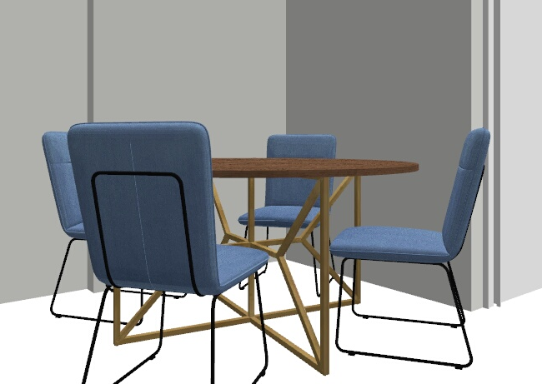
3D Rendering: This area would serve as an additional, accessible study, waiting, or device charging area.
Concept Photo

The Global Swap round table (36”x36”x36”) and four Ki Strive chairs would work well in this area.
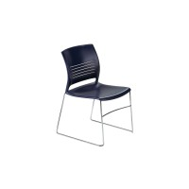
The corner nook toward the right hallway would serve as a spot for two benches, an ottoman, and two outlets. There is also the possibility of a small table between the benches, although that has not been quoted at this time. Other than running wires for outlets on the two walls, the only other OM task would be to relocate the red fire extinguisher box from this wall to a wall in the nearby alcove.
Concept Photo: Actual Product
3D Rendering: Seating with charging outlets added on walls.

Two Global Citi benches and an OFS Boost Round Ottoman are suggested items for this corner. Both pieces can be upholstered in a durable vinyl that can be cleaned easily with Clorox-type wipes.

The last item for this upstairs area would be a wall mounted magazine rack to hold course advertisements and information sheets to assist students in choosing courses. This would be mounted on the wall near the restrooms.
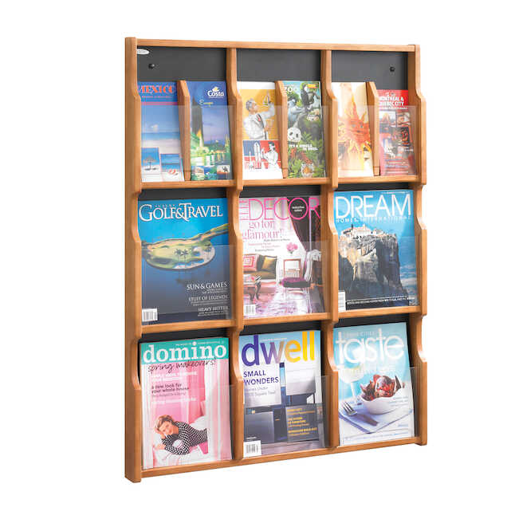
Safco product (no quoted price given yet.)
Demco product

Price Breakdown: (As of 2019)

BDH 2nd Floor Central Area

Alcove by front window
Item | Size | QTY | Price Per Item | Total
Global Swap Table | 30x96x42h | 1 | $1,070.00 | $1,070.00
Ki Strive Café Stool (poly café stool) |  | 4 | $185.00 | $740.00
Central Area
Global Swap Table | 36x36x36 | 1 | $494.45 | $494.45
Ki Strive Chair |  | 4 | $133.90 | $535.60
Citi Two Seat Bench | 43x21.5x17 | 2 | $449.90 | $899.80
OFS Boost Round Ottoman | 25.5x25.5x17.75 | 1 | $522.50 | $522.50
Wooden Mallett Oak & Acrylic Wall Display | Demco | 1 | $284.99 | $284.99
 |  |  |  | $4547.34
Budget Breakdown | Budgeted | Spent
Original Budget (Dr. Owens) | $3000.00 | $3000.00
Communications Budget Goal 2 OBJ 4 | $1000.00 | $773.67
Communications Budget Goal 2 OBJ 6 | $300.00
Liberal Arts Budget Goal 2 OBJ 4 | $1000.00 | $773.67
Liberal Arts Budget Goal 2 OBJ 6 | $300.00
TOTAL | $5,600.00 | $4,547.34
*Budgeted amount has been raised to account for anticipated price increases.

Classroom Furniture P.O. from April 2021
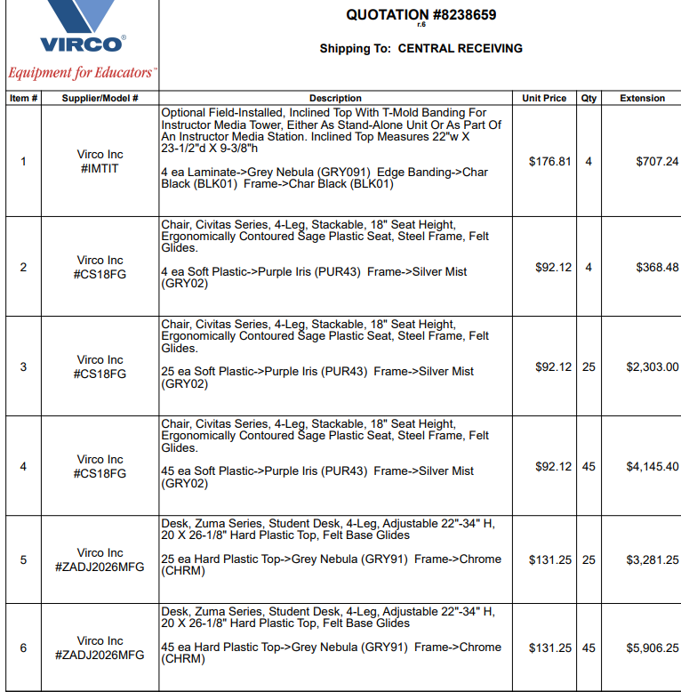
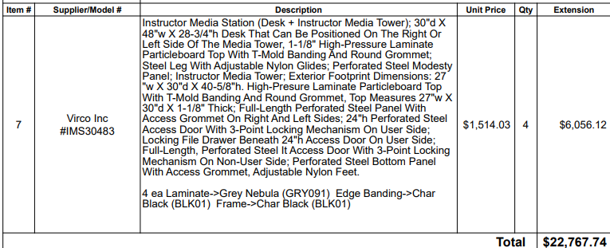

College Scholars Buzzer System
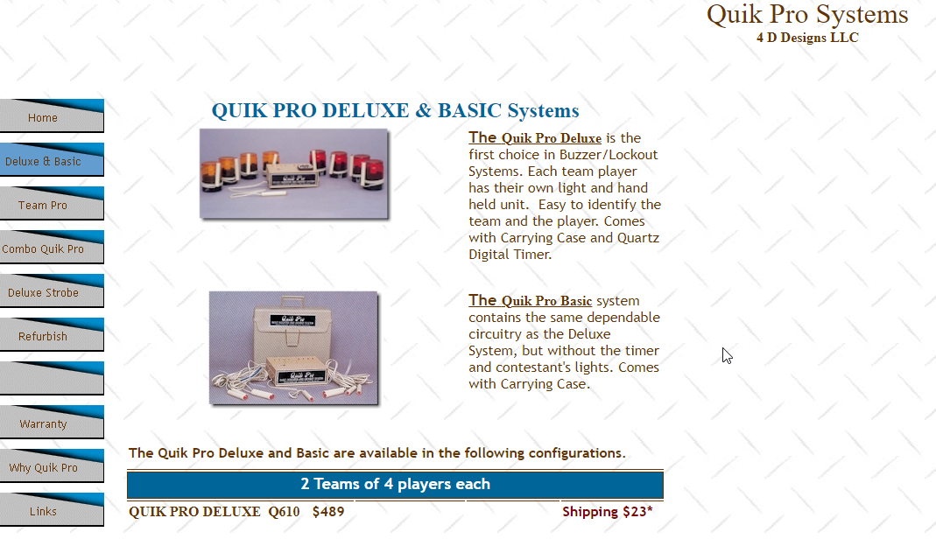

I met with Lynn Harris regarding the feasibility of adding 7-8 outlets with USB charging capabilities in this area. He said that he could drop the wires from the ceilings and cover them with wire covers painted to match the décor.

