Unit Strategic Plan
2021-2023

Department: Liberal Arts-Jefferson Campus

Mission Statement (for the program or department):
The mission of the Liberal Arts Department is consistent with the mission of the college. The department is dedicated to offering a curriculum that develops students into well-rounded individuals who become contributing members of society and have an appreciation for the arts, humanities and social sciences. The Liberal Arts Department offers courses and programs that provide a quality educational experience in the liberal arts tradition. The Liberal Arts Department is divided into two areas-Humanities and Social Sciences.
The Humanities area of this department is dedicated to providing valuable learning experiences in the liberal arts tradition. The department is committed to offering those courses which will present the student an excellent opportunity to pursue moral, creative, and philosophical interests. Courses within this curriculum include art, music, religion, and philosophy. The Social Science area of this department also acknowledges the liberal arts tradition. It is committed to creating a learning environment of self-awareness along with a sense of growth and development. Courses in this curriculum include anthropology, geography, history, political science, psychology, and sociology.
Department Level Student Learning Outcomes
- Enable students, through various disciplines, to discover, develop and use their full range of abilities to better understand the world and their place in it.
- Provide students with a foundation of knowledge on which more advanced learning in the various disciplines and majors can later build.
- Enable students to reason and communicate clearly and to inquire deeply.
Summary of Access, Productivity and Effectiveness:
Courses offered in Liberal Arts are open to all students. However, students enrolling in the choral ensemble (MUL) must audition for admission. The Liberal Arts Department continues to produce many credit hours with a total of 10,179 for the Jefferson Campus during the 2019-2020 academic year. The bulk of the Liberal Arts enrollment is generated by Psychology (3138 CHP), History (1920 CHP), and ART (1917 CHP) during the 2019-2020 academic year. The largest student demographic falls between the ages of 18-25. However, we serve accelerated and dual enrolment students as well as non-traditional students. We also serve a diverse ethnic population, including many second-language learners.

Annual Credit Trend by Department 2018-2019, 2019-2020, 2020-2021

Jefferson Campus
Department | 2018-2019 |  | 2019-2020 |  | 2020-2021
 | Total  Registrations | Credit  Hour  Production | Total  Registrations | Credit  Hour  Production | Total  Registrations | Credit  Hour  Production
ART | 624 | 1872 | 639 | 1917 | 659 | 1977
GEO | 132 | 396 | 115 | 345 | 131 | 393
HIS | 697 | 2091 | 640 | 1920 | 699 | 2097
HUM | 43 | 93 | 45 | 135 | 87 | 261
MUL | 123 | 185 | 113 | 171 | 66 | 100
MUS | 111 | 333 | 90 | 270 | 176 | 528
POL | 23 | 69 | 41 | 123 | 100 | 300
PSY | 1050 | 3150 | 1046 | 3138 | 1000 | 3000
REL | 198 | 594 | 194 | 582 | 182 | 546
SOC | 302 | 906 | 464 | 1392 | 526 | 1578
THR | 154 | 462 | 62 | 186 | 0 | 0

Reflections/Implications on the Jefferson Campus:
Since AY 2018-2019, the Jefferson Campus has experienced an increase in enrollment in the following subject areas: ART (+6%), HUM (+181%), MUS (+59%), POL (+334%), and SOC (75%). The department believes these increases are a direct result of the increased online offerings, especially from Summer 2020 through the entire AY 2020-2021, because of the COVID-19 pandemic when almost all courses were moved online. Other subject areas such as GEO, experienced a decrease in enrollment during the 2019-2020 academic year; however, by 2020-2021, the enrollment was almost identical to the 2018-2029 year. Furthermore, because of the newly implemented ACCS scheduling system, online courses are no longer tied to a physical campus and instead are cited at the Online Campus (OL). To determine the CHP for these courses, the department counted courses taught by instructors who are scheduled by the Jefferson Campus. Because the online THR courses are taught by instructors based at other campuses, it appears that no students from the Jefferson Campus enrolled in a THR course. This was not likely the case. Finally, there was a slight decrease in enrollment in a few areas, including MUL (-46%), PSY (-5%), and REL (-8%). While any decrease is concerning, these numbers may be a result of the pandemic year. The department will continue to monitor enrollment in all Liberal Arts subject areas.

Internal Conditions:

Technology
Keeping computers and other technology for faculty and classrooms current is an ongoing need. The department, upon consultation with IT, sets a four to five-year rotation plan for upkeep of equipment. The Liberal Arts classrooms in BDH, HYC, and FSC are equipped with a computer, a projector, and a screen. All rooms with technology had equipment replaced and updated as of the 2014-2015 academic year. We will continue to monitor these rooms and request updates or upgrades to equipment as it ages, becomes obsolete, or wears out. In 2019-2020 and 2020-2021, the computers in the Art Graphics lab and the Adobe software have been upgraded to industry standards. The software requires a yearly license purchase.

All Liberal Arts instructors utilize computers in their offices for online instruction and preparation of instructional materials, creation of exams, record keeping, communication, etc. Some instructors utilize a dual monitor setup. Instructor computers are upgraded as needed, or as the computers age out of usefulness and warranty. Laptops do require replacement sooner than desktops. All instructors but one utilize VOIP phones. That instructor’s office is currently being wired to accommodate the upgraded phone.

The Division office in 219 has three computers (2 desktop/1 laptop with docking station). The office manager’s computer was purchased in the 2019-2020 year; the chair’s laptop was replaced in the 2019-2020 year. The other computer in the office was purchased in the 2014-2015 year. Both the office manager and the chair utilize a dual monitor setup. There are two printers in BDH 219: a large, networked copier/scanner/printer and a color laser printer. A desktop scanner, a small printer in BDH 209, and a Scantron grading machine are also available for faculty use. Both the chair and the office manager have VoIP telephones.
In the Part Time Office in 209, there are two computers that are shared with Liberal Arts Part Time instructors.
Summary Table: Age of Faculty Office Computers
OFFICES |  | COMPUTER
BDH 209 A |  | 2019-2020
BDH 209 B |  | 2016-2017
BDH 209 C (previously in GLB 219) |  | 2019-2020
BDH 209 D |  | 2016-2017
BDH 209 (PT office) |  | 2015-2016
FSC (Choir Director) |  | 2020-2021
HYC 300 |  | 2016-2017
BDH 219  (DIV. OFFICE) | CHAIR -L | *2019-2020
 | OFFICE MGR-D | *2020-2021
 | OFFICE –D | *2014-2015
(*Also counted on Communication’s Budget)

Budget
The budget for classroom and office supplies is sufficient and genuinely appreciated by the faculty.

Staffing
Beginning with the 2021-2022 academic year, the Liberal Arts Department will have six full-time instructors (1 ART, 1 HIS, 1 MUS, 2 PSY, 1 SOC). One psychology instructor retired in 2021; however, the full-time instructor at Clanton transferred to the Jefferson Campus. Should any other changes occur, we will submit a request for additional faculty. We currently utilize six part time instructors in on-campus, online, and dual enrollment courses. There is also one full-time office manager for the Division of Communications and Liberal Arts, as well as two current work study students. Full-Time Faculty are responsible for the majority of our Credit Hour Production in all subject areas except for history, geography, and religion. The full-time history instructor teaches one section of political science twice a year, so during those semesters, she teaches one less history course. The geography and religion courses are taught online by Part-Time faculty.
Percentage of Full Time Faculty – Jefferson Campus
Department | 2018 -2019 |  | 2019-2020 |  | 2020-2021
 | Total  Registrations | Full Time Faculty Percentage | Total  Registrations | Full Time Faculty Percentage | Total  Registrations | Full Time Faculty Percentage
ART | 624 | 70.8% | 639 | 71% | 659 | 79%
GEO | 132 | 0% | 115 | 0% | 131 | 0%
HIS | 697 | 60.3% | 640 | 49% | 699 | 53%
HUM | 43 | 87.1% | 45 | 100% | 87 | 100%
MUL | 123 | 100% | 113 | 100% | 66 | 100%
MUS | 111 | 100% | 90 | 100% | 176 | 100%
POL | 23 | 100% | 41 | 100% | 100 | 100%
PSY | 1050 | 100% | 1046 | 100% | 1000 | 100%
REL | 198 | 0% | 194 | 0% | 182 | 0%
SOC | 302 | 97.4% | 464 | 98% | 526 | 91%
THR | 154 | 70.1% | 62 | 100% | 0 | 100%

Resources
Faculty members are grateful to the college for providing funding to support professional development opportunities, including IAP funds. Faculty members are encouraged to attend and present at conferences, upgrade their computer skills, and complete studies that help them to remain relevant in their fields. The department respectfully requests that this funding continue.

Enrollment
During summer terms, we have seen a lower enrollment in traditional classes, and we have adjusted our offerings accordingly. The demand for online classes remains high due to the large number of transient students we serve. Overall, enrollment in online classes has impacted enrollment in traditional classes as the number of online classes have increased. Course offerings are adjusted according to enrollment trends. Of note in the data below is that beginning in Summer 2020, most courses were taught online due to the COVID pandemic. Only a few approved courses were offered on campus. The numbers in the online sections below are courses taught by instructors assigned from the Jefferson Campus.
Enrollment per Course at Jefferson Campus AY 2019-2020 and AY 2020-2021
2019-2020 |  |  |  |  |  |  |  |  | 2020-2021
Course | Traditional |  |  |  | Online |  |  |  | Traditional |  |  |  | *Online
 | F | SP | SU | Total | F | SP | *SU | Total | F | SP | SU | Total | F | SP | SU | Total
ART 100 | 89 | 49 | 0 | 138 | 85 | 82 | 140 | 307 | 0 | 0 | 0 | 0 | 174 | 91 | 122 | 387
ART 113 | 15 | 11 | 0 | 26 | 0 | 0 | 0 | 0 | 0 | 0 | 0 | 0 | 19 | 14 | 0 | 33
ART 114 | 0 | 4 | 0 | 4 | 0 | 0 | 0 | 0 | 0 | 0 | 0 | 0 | 0 | 0 | 0 | 0
ART 121 | 0 | 0 | 0 | 0 | 0 | 0 | 0 | 0 | 0 | 0 | 0 | 0 | 0 | 13 | 0 | 13
ART 127 | 0 | 0 | 0 | 0 | 0 | 0 | 0 | 0 | 0 | 0 | 0 | 0 | 0 | 0 | 0 | 0
ART 203 | 16 | 0 | 0 | 16 | 45 | 0 | 27 | 72 | 0 | 0 | 0 | 0 | 94 | 50 | 32 | 176
ART 204 | 0 | 12 | 0 | 12 | 0 | 45 | 0 | 45 | 0 | 0 | 0 | 0 | 0 | 33 | 0 | 33
ART 220 | 0 | 8 | 0 | 8 | 0 | 0 | 0 | 0 | 0 | 0 | 0 | 0 | 0 | 0 | 0 | 0
ART 283 | 0 | 11 | 0 | 11 | 0 | 0 | 0 | 0 | 7 | 0 | 0 | 7 | 0 | 9 | 0 | 9
ART 284 | 0 | 0 | 0 | 0 | 0 | 0 | 0 | 0 | 0 | 0 | 0 | 0 | 0 | 0 | 0 | 0
GEO 100 | 0 | 0 | 0 | 0 | 44 | 30 | 41 | 115 | 0 | 0 | 0 | 0 | 40 | 46 | 45 | 131
HIS 101 | 63 | 45 | 0 | 108 | 0 | 0 | 0 | 0 | 0 | 0 | 0 | 0 | 70 | 0 | 0 | 70
HIS 102 | 20 | 27 | 0 | 47 | 0 | 0 | 21 | 21 | 0 | 0 | 0 | 0 | 35 | 40 | 51 | 126
HIS 201 | 63 | 21 | 0 | 84 | 113 | 40 | 36 | 189 | 0 | 0 | 0 | 0 | 229 | 159 | 0 | 388
HIS 202 | 22 | 30 | 0 | 52 | 75 | 0 | 64 | 139 | 0 | 0 | 0 | 0 | 44 | 34 | 37 | 115
HUM 298A | 7 | 6 | 0 | 13 | 0 | 0 | 0 | 0 | 4 | 3 | 0 | 7 | 0 | 0 | 0 | 0
HUM 298M | 0 | 0 | 0 | 0 | 0 | 0 | 32 | 32 | 0 | 0 | 0 | 0 | 72 | 15 | 0 | 87
MUS 101 | 51 | 16 | 0 | 67 | 0 | 0 | 23 | 23 | 0 | 0 | 0 | 0 | 91 | 85 | 0 | 176
MUL 180 | 15 | 14 | 0 | 29 | 0 | 0 | 0 | 0 | 11 | 13 | 0 | 24 | 0 | 0 | 0 | 0
MUL 181 | 16 | 13 | 0 | 29 | 0 | 0 | 0 | 0 | 4 | 6 | 0 | 10 | 0 | 0 | 0 | 0
MUL 182 | 16 | 12 | 0 | 28 | 0 | 0 | 0 | 0 | 8 | 11 | 0 | 19 | 0 | 0 | 0 | 0
MUL 183 | 13 | 14 | 0 | 27 | 0 | 0 | 0 | 0 | 7 | 6 | 0 | 13 | 0 | 0 | 0 | 0
POL 211 | 10 | 0 | 0 | 10 | 10 | 0 | 21 | 31 | 0 | 0 | 0 | 0 | 41 | 42 | 17 | 100
PSY 200 | 140 | 103 | 0 | 243 | 108 | 109 | 93 | 310 | 0 | 0 | 0 | 0 | 365 | 338 | 74 | 777
PSY 210 | 57 | 48 | 0 | 105 | 181 | 110 | 97 | 388 | 0 | 0 | 0 | 0 | 102 | 109 | 12 | 223
REL 151 | 0 | 0 | 0 | 0 | 33 | 46 | 0 | 79 | 0 | 0 | 0 | 0 | 34 | 45 | 0 | 79
REL 152 | 0 | 0 | 0 | 0 | 48 | 44 | 23 | 115 | 0 | 0 | 0 | 0 | 39 | 45 | 19 | 103
SOC 200 | 56 | 32 | 0 | 88 | 89 | 99 | 144 | 332 | 0 | 0 | 0 | 0 | 142 | 139 | 99 | 480
SOC 210 | 0 | 0 | 0 | 0 | 0 | 33 | 0 | 33 | 0 | 0 | 0 | 0 | 0 | 34 | 0 | 34
SOC 247 | 0 | 0 | 0 | 0 | 11 | 0 | 0 | 11 | 0 | 0 | 0 | 0 | 12 | 0 | 0 | 12
THR 120 | 36 | 26 | 0 | 62 | 0 | 0 | 0 | 0 | 0 | 0 | 0 | 0 | 0 | 0 | 0 | 0
*Online courses taught by instructors assigned from the Jefferson Campus. Beginning in Summer 2020, most courses were taught online due to the COVID pandemic. Only a few approved courses were offered on campus.

Facilities
The Liberal Arts Department offers classes in Bethune-DeRamus Hall, H.Y. Carson Hall (Art) and Fitzgerald Student Center (Music/Choir). The department utilizes five classrooms in BDH (200, 201, 208, 210, 216), four dedicated classrooms in HYC (300, 301, 305, 306, and sometimes for large classes 212), and a classroom (JR) and choir room (PII) in FSC. Of the classroom space for Art in HYC, rooms 300, 301, and 306 are studio spaces.
Liberal Arts faculty has adequate office space in BDH, utilizing four offices in a suite: 209 A, B, C, and D. One instructor has office space in H.Y. Carson (300), and one instructor has office space in Fitzgerald Student Center.
Four unoccupied offices in BDH are currently being used by Liberal Arts and Communications for department storage or by student organizations. We converted unused space in BDH 211 into a make-up testing room for Communications and Liberal Arts, which is available for students to use for study purposes when it is not being used for testing. The department is now considering turning this space into a study room for students to reserve for in person group study sessions. The Part-Time Instructor workroom in 209 is shared with Communications. This space is large and open, providing a place for Part-Time instructor mailboxes, a computer, worktables, instructor file storage, department storage, and a refrigerator and microwave (although these appliances are ancient). This area also provides VOIP telephones for part-time instructors to use. The bookroom is housed in 217.
Classroom and office spaces are adequate. All faculty offices have been upgraded with office ensembles that provide a more professional office space.
The Division Office in 219 houses the Chair, Office Manager, full-time faculty mailroom, storage and secure file areas, a small workroom, and work study students. The office suite includes space for secure storage, a waiting area, a copy/scantron area, and a break room.
In 2018-2019, the department upgraded the furniture in the Art Department for the safety and comfort of our students. In 2020, the department began replacing the student desks in the classrooms. BDH 216 was the first Liberal Arts classroom upgraded with 45 new student desks and separate chairs. In 2021, BDH 208 was upgraded with 45 new student desks and chairs, and both BDH 216 and 208 received new instructor tables with an attached media station and lectern top. The plan is to replace student and instructor desks in BDH 210 in AY 2021-2022, and then seek to replace furniture in one classroom each year until all rooms have been updated.

Equipment
In addition to the technologic equipment previously mentioned, the department also has DVD/VCR combs in some classrooms. These units are not supported by newer projectors. In addition, we have three portable TV sets that can be moved from room to room, although these are rarely used. Other specialized equipment:

Classroom | Pre-2015-2016 | Yearly License
HYC 300/301/305 (Computer Graphics/Ani-mation Lab) | 2Printer/  Scanner/ Copiers Dell 2155 cdn | Toon Boom – Harmony Pro software
 | Logitech HD 10 Webcam
 | Digital Camera (donation)
 | 16 Apple Computers
 | 8 Wacom Tablets
 | 3 Gaphic Cintiq Tablets
HYC 306 (Lecture classroom) | Computer
FSC PII/JR | 3 pianos
 | Computer (JR)
 | Sound System

External Conditions
The division’s accreditation comes through the college’s general accreditation with the Southern Association of Colleges and Schools—SACS-COC. The college completed a three-year program review in 2019, as well as a three-year assessment cycle. The department has made appropriate adjustments based upon the data.
The division is impacted by Post-Secondary policy changes when applicable. The ASGC updated the Course Outcomes for all courses in Liberal Arts. These updates were fully implemented beginning in Fall 2021. The department uses the STARS articulation guide to inform its curriculum and course offerings.

2019-2020 Accomplishments:
- Instructors utilizing textbook software received training from the publishing companies.
- Faculty members attended various workshops provided by the College, including ADA Compliance, Pioneer Con, Black History Program, and Constitution Day.
- Two department faculty members completed the ACCS Instructional Leadership Academy (ILA).
- The art instructor participated in webinars sponsored by ACME Networks.
- SLOs and assessments were reviewed by the faculty, along with the implementation of a shared spreadsheet for data collection.
- The ART department continued the ACME Network animation partnership for an additional year.
- The ART department updated its Toon Boom software to industry standards; however, it has not been installed as there are compatibility issues with the network.
- Replacement chairs and stools were purchased for one art studio.
- Student desks in BDH 216 were updated with new desks with separate chairs.

2020-2021 Accomplishments:
- One instructor completed the Instructional Leadership Academy (ILA), The department also purchased a subscription to The Chronicle of Higher Education.
- Most instructors participated in the Online Learning Consortium Workshops relating to Engagement, ADA, and Feedback.
- Several instructors completed the Applying the Quality Matters Rubric Course online.
- SLOs and assessments were reviewed, and instructors meet to discuss changes, best practices, and implementation of instructional strategies based on assessment results.
- The department offered financial support to the Concert and Lecture series.
- The ART department continued the ACME Network animation partnership.
- The department purchased items requested by instructors on departmental surveys.
- Department faculty served on various college committees including, Curriculum, Social, Black History, Distance Education, Developmental Education, Dual Enrollment, Planning Council, and New Student Orientation.
- The art department purchased additional task chairs, mid-back drawing stools, and drawing easels for art studio classrooms.
- The department purchased 45 new student desks and chairs for BDH 208 and two instructor tables with media stations for BDH 208 and BDH 216.

Unit Goals for 2021-2022

Goal 1: Maintain an informed and professional faculty to preserve the ability to offer courses to help students meet their educational and transfer goals.

OBJ. 1: Provide support for professional development.
- Provide professional development activities on campus through roundtable discussions, guest speaker presentations, and workshops for faculty to maintain knowledge of current trends and technology in their fields.
- Encourage faculty to attend local, in-state, and out-of-state conferences.
- Encourage faculty to submit proposals to present at local, in-state, and out-of-state conferences.

Method of Assessment for Objective 1:
- Survey faculty by using Google Forms to determine areas of interest to plan the on-campus sessions for each semester. Following each session, participants will evaluate the session.
- Provide workshops where faculty who have specialized knowledge in technology provide training to other faculty to enhance instruction (Office 365 for Instructors, Blackboard tutorials, Presentation Platforms, Creating Instructional Videos for Online Classes, etc.)
- Offer training on campus for faculty relating to using technology to improve instruction, including the LMS system and textbook software.
- Review faculty Individual Action Plans for meaningful professional development opportunities, track the number of grants and requests submitted, and track the number of faculty attending conferences.
- Track the number of faculty submitting proposals for presentations at conferences.
- Ask faculty who have attended conferences to share their experiences with faculty.
- Track the number of faculty submitting proposals for presentations at conferences.

OBJ 2: Enhance the effectiveness of Liberal Arts courses by encouraging instructors to collaborate on best practices, methods, and assignments in the subject areas.

Method of Assessment for Objective 2:
- Set up a TEAMS group for each subject area and offer training on how to use the site for collaboration.
- Encourage faculty to meet at least once each semester to share ideas and teaching strategies and to plan for the upcoming semester/year.

OBJ. 3: Continue to staff courses with qualified instructors.

Method of Assessment for Objective 3:
- Evaluate enrollment numbers and FT/PT ratios to determine the need for hiring additional faculty. If the enrollment numbers warrant, the necessary requests for personnel will be submitted to the administration for approval.
- Review applications and conduct interviews for additional part-time instructors as needed.

2021-2022 Total Funds Requested for Goal #1: $58,150.00

Goal #1: Maintain an informed and professional faculty to preserve the ability to offer courses to help students meet their educational and transfer goals.
 | OBJ. 1: Provide support for professional development.
 |  | Breakdown of Requested Amounts | Description of how funds will be used to accomplish objective.
 |  | $1000.00 | Purchase license/registration for online seminars, journal subscriptions, or to pay honoraria for workshops provided by guest lecturers/professors.
 |  | $150.00 | Institutional membership in the American Choral Directors’ Association and attendance at the Alabama meeting.
 |  | $2000.00 | Support conference attendanceor professional development opportunities for faculty. Requests will be supported on a first come/first serve basis (after application of IAP funds) until the budget is exhausted.
 | OBJ 2: Enhance the effectiveness of Liberal Arts courses by encouraging instructors to collaborate on best practices, methods, and assignments in the subject areas
 |  | NONE | No support is needed for OBJ. 2
 | OBJ. 3: Continue to staff courses with qualified instructors.
 |  | $55,000.00 | Hire an additional Liberal Arts teacher if necessary.

Goal 2: Provide academic, developmental, and support services to assist students in achieving their academic goals, as well as fostering intellectual inquiry and creative growth.

OBJ. 1: Continue financial support for the Concert and Lecture Series.

Method of Assessment for Objective. 1:
- Monitor offerings and attendance at Concert and Lecture series events.

OBJ. 2: Support the choir through their attendance at conventions, festivals, workshops, and concerts.

Method of Assessment for Objective. 2:
- Monitor requests by the choir for support.

OBJ. 3: Support the Art and Animation Guild with assistance for projects and Art Shows.

Method of Assessment for Objective. 3:
- Monitor requests by the Art and Animation Guild for support.

OBJ. 4: Offer a welcoming environment for students in the department equipped with seating and study space, as well as attractive informational bulletin boards and books to read.

Method of Assessment for Objective. 4:
- Follow up on previously submitted proposal and resubmit with revisions if necessary.

OBJ. 5: Continue to review Student Learning Outcomes and assessments for each course.

Method of Assessment for Objective 5:
- Study data derived from assessment to determine how to best modify instruction to encourage mastery of each SLO.
- Implement changes to SLOs and assessment
- Conduct faculty reviews of SLOs for each course to determine the need for changes in the next three-year cycle.
- Revise course objectives/competency documents as needed.

OBJ. 6: Create a Course Information Exhibit to provide specific course information (beyond the catalog) to increase enrollment in on-campus courses.

Method of Assessment for Objective 6:
- Create informational pamphlets on each course offered in the department.
- Set up a wall-mounted display center in BDH with information accessible to students.
- Prepare exhibits and manned- tables during Registration and Advising times to engage students.

2021-2022 Total Funds Requested for Goal #2: $6,050.00

Goal #2: Provide academic, developmental, and support services to assist students in achieving their academic goals, as well as fostering intellectual inquiry and creative growth.
 |  | OBJ. 1: Continue financial support for the Concert and Lecture Series.
 |  |  | Breakdown of Requested Amounts | Description of how funds will be used to accomplish objective.
 |  |  | $500.00 | Support the concert portion of the Concert and Lecture Series. (Shelby is requesting the same amount.)
 |  | OBJ. 2: Support the choir through their attendance at conventions, festivals, workshops, and concerts.
 |  |  | $1200.00 | Support the Choir’s attendance at the Alabama Collegiate Choral Festival, including bus rental.
 |  |  | $400.00 | Instrumentalists and sound recording technicians for choral concerts
 |  |  | $700.00 | Piano tuning for the choir
 |  |  | $150.00 | Water cooler supplies for choir’s rehearsals
 |  | OBJ. 3: Support the Art and Animation Guild with assistance for projects and Art Shows.
 |  |  | $1000.00 | Support the Art and Animation Guild’s activities on campus and in the community.
 |  | OBJ. 4: Offer a welcoming environment for students in the department equipped with seating and study space, as well as attractive informational bulletin boards and books to read.
 |  |  | $1,000.00 | Furnishings for the Student area on the second floor of BDH. Please see full proposal. (This budget item is in addition to the $3000.00 provided by the Leadership Academy’s project and the amount requested through the Communications budget.)
 |  |  | $250.00 | Stand or cabinet for Microwave oven if purchased allowed in Communications budget.
 |  | OBJ. 5: Continue to review Student Learning Outcomes and assessments for each course.
 |  |  | NONE | No funding requested for OBJ. 5.
 | OBJ. 6: Create a Course Information Exhibit to provide specific course information (beyond the catalog) to increase enrollment in on-campus courses.
 |  |  | $300.00 | Wall mounted 12-16 space pamphlet holder
 |  |  | $150.00 | Candy, snacks, etc. for table displays during on-campus events
 |  |  | $ 400.00 | Printing course pamphlets

Goal 3: Maintain classroom and office equipment and supplies to enhance the quality of instruction and improve student learning.

OBJ. 1: Enhance student learning and the quality of instruction offered to students through using up-to-date, appropriate equipment, furniture, and technology in the classrooms.

Methods of Assessment for Objective 1:
- Upgrade 16 computers in the Art computer lab to align with industry standards. (The current computers cannot accommodate the updated programs and are all in need of replacing.)
- Upgrade to Adobe Animate through the latest Adobe Suite CS20. (The version we have is Adobe Creative Suite CS6; this is totally out of date and no longer supported.)
- Replace classroom computers, projectors, and other equipment as needed to offer quality instruction and enhance student learning.
- Replace classroom furniture (i.e., student desks, lecterns, instructor desk area) as needed (and as the budget allows) to create a more comfortable and modern classroom experience and an enhanced learning environment for students.
- Monitor the purchase, installation, and updating of classroom software and hardware to ensure currency.
- Survey faculty to determine the need for upgraded or new equipment, furniture, and technology for use in the classrooms.
- Offer training on campus for faculty relating to using technology to improve instruction, including the LMS system, document cameras, recording software, and textbook software.
- As classroom equipment fails or needs upgrading, it shall be reported and requested to be replaced to maintain functionality and currency.
- Requisitions will be processed for equipment requested through the technology plan upon approval and on an as-needed basis.

OBJ. 2: Replace faculty and staff computers, software, furniture, and other equipment as needed to ensure faculty continue to function as effective instructors.

Methods of Assessment for Objective 2:
- Survey faculty to determine needs.
- As equipment fails or needs upgrading, it shall be reported and requested to be replaced to maintain functionality and currency.
- Requisitions will be processed for equipment requested through the technology plan upon approval and on an as-needed basis.
- Submit requests to replace consumable supplies and furniture/equipment as needed to the administration for approval.

OBJ. 3: Enhance the quality of Art instruction offered to students through a safe, comfortable, and welcoming classroom environment conducive to learning.

Methods of Assessment for Objective 3:
- Replace student seating for Art and Animation and the Drawing studio.
- Repair windows in art and animation studios to prevent drafty conditions.
- Add window blinds in the studio to control lighting.
- Place display boards in the hallways to display student artwork.

OBJ. 4: Encourage instructors to evaluate new technology and equipment by piloting projects in their courses.

Methods of Assessment for Objective 4:
- Survey faculty to identify those who wish to pilot new methods and technology. Faculty will submit a plan/proposal, and the budget will be planned accordingly for necessary purchases.

2021-2022 Total Funds Requested for Goal #3: $44,498.26

Goal #3: Maintain classroom and office equipment and supplies to enhance the quality of instruction and improve student learning.
 | OBJ. 1: Enhance student learning and the quality of instruction offered to students through using up-to-date, appropriate equipment, furniture, and technology in the classrooms.
 |  | Breakdown of Requested Amounts | Description of how funds will be used to accomplish objective.
 |  | $5906.25 | Desk Zuma Series x 45 to replace student desks in BDH 210 (Virco) *Estimate based on April 2021 purchase.
 |  | $4,237.52 | Civitas Series chairs x 46 to replace student seating in BDH 210 (includes one chair for instructor seating per room) (Virco) *Estimate based on April 2021 purchase.
 |  | $1,514.03 | Instructor media station (media tower and peninsula desk) for BDH 210 (Virco) *Estimate based on April 2021 purchase.
 |  | $176.81 | Lectern top for media station in BDH 210. (Virco) *Estimate based on April 2021 purchase.
 |  | $1100.00 | Room darkening shades/blinds for BDH 216 and BDH 208
 |  | $1000.00 | Purchase educational materials (books/software/posters) for classroom use.
 |  | $12,500.00 | ACME Network animation fee (Jefferson and Shelby classes) for 1 year
 |  | $4443.75 | Adobe Animate Suite CS20 (Current version of Adobe Creative Suite is CS6; the latest up to industry standards is CS20.) -License must be renewed yearly.
 | OBJ. 2: Replace faculty and staff computers, software, furniture, and other equipment as needed to ensure faculty continue to function as effective instructors.
 |  | $3,690.00 | 3 Replacement computers for instructors (BDH 209B, BDH 209C, CH 300)
 |  | $200.00 | Small bookcase for instructor office (BDH 209B)
 |  | $5,000.00 | Emergency fund to replace instructor computers that fail unexpectedly
 | OBJ. 3: Enhance the quality of Art instruction offered to students through a safe, comfortable, and welcoming classroom environment conducive to learning.
 |  | $1149.90 | 10 Display Frames for student artwork (Blick)
 |  | $2,580.00 | 12 midback drafting stools for studio (will complete furniture replacement)
 |  |  | 28 rubber stoppers for art stools already purchased (safety issue)
 | OBJ. 4: Encourage instructors to evaluate new technology and equipment and pilot projects in their courses.
 |  | $1000.00 | Purchase of necessary materials for piloting new technology, equipment, and materials.

Unit Goals for 2022-2023

Goal 1: Maintain an informed and professional faculty to preserve the ability to offer courses to help students meet their educational and transfer goals.

OBJ. 1: Provide support for professional development.
A. Provide professional development activities on campus through roundtable discussions, guest speaker presentations, and workshops for faculty to maintain knowledge of current trends and technology in their fields.
B. Encourage faculty to attend local, in-state, and out-of-state conferences.
C. Encourage faculty to submit proposals to present at local, in-state, and out-of-state conferences.

Method of Assessment for Objective 1:
- Implement a book club reading for faculty.
- Survey faculty by using Google Forms to determine areas of interest to plan the on-campus sessions for each semester. Following each session, participants will evaluate the session.
- Provide workshops where faculty who have specialized knowledge in technology provide training to other faculty to enhance instruction (Office 365 for Instructors, Blackboard tutorials, Presentation Platforms, Creating Instructional Videos for Online Classes, etc.)
- Offer training on campus for faculty relating to using technology to improve instruction, including the LMS system and textbook software.
- Review faculty Individual Action Plans for meaningful professional development opportunities, track the number of grants and requests submitted, and track the number of faculty attending conferences.
- Track the number of faculty submitting proposals for presentations at conferences.
- Ask faculty who have attended conferences to share their experiences with faculty.

OBJ. 3: Continue to staff courses with qualified instructors.

Method of Assessment for Objective 3:
- Evaluate enrollment numbers and FT/PT ratios to determine the need for hiring additional faculty. If the enrollment numbers warrant, the necessary requests for personnel will be submitted to the administration for approval.
- Review applications and conduct interviews for additional part-time instructors as needed.

2022-2023 Total Funds Requested for Goal #1: $58, 150.00

Goal #1: Maintain an informed and professional faculty to preserve the ability to offer courses to help students meet their educational and transfer goals.
 | OBJ. 1: Provide support for professional development.
 |  | Breakdown of Requested Amounts | Description of how funds will be used to accomplish objective.
 |  | $1000.00 | Purchase license/registration for online seminars, journal subscriptions, or to pay honoraria for workshops provided by guest lecturers/professors.
 |  | $150.00 | Institutional membership in the American Choral Directors’ Association and attendance at the Alabama meeting.
 |  | $2000.00 | Support conference attendance for faculty. Requests will be supported on a first come/first serve basis (after application of IAP funds) until the budget is exhausted.
 | OBJ. 2: Continue to staff courses with qualified instructors.
 |  | $55,000.00 | Hire an additional Liberal Arts teacher if necessary.

Goal 2: Provide academic, developmental, and support services to assist students in achieving their academic goals, as well as fostering intellectual inquiry and creative growth.

OBJ. 1: Continue financial support for the Concert and Lecture Series.

Method of Assessment for Objective. 1:
- Monitor offerings and attendance at Concert and Lecture series events.

OBJ. 2: Support the choir through their attendance at conventions, festivals, workshops, and concerts.

Method of Assessment for Objective. 2:
- Monitor requests by the choir for support.

OBJ. 3: Support the Art and Animation Guild with assistance for projects and Art Shows.

Method of Assessment for Objective. 3:
- Monitor requests by the Art and Animation Guild for support.
- Work with the AAG to determine the feasibility of an Art and Writing symposium for spring semester where students from art, English, or other liberal arts classes could showcase their works.

OBJ. 4: Offer a welcoming environment for students in the department equipped with seating and study space.

Method of Assessment for Objective. 4:
- Remove old study carrels from the old Lynn Hope Moody Reading Rooms (current make up testing room
- Purchase items to outfit space as needed.

OBJ. 5: Continue to review Student Learning Outcomes and assessments for each course.

Method of Assessment for Objective 5:
- Compile semester data, annual reviews, and 3-year reviews and work to create an efficient and effective method of compiling the data.
- Provide training for instructors in how to collect the data and complete the spreadsheet.
- Meet with FT faculty in each to discuss the overall subject area results and plan how to proceed in the future.
- Encourage active participation from each subject area in data compilation, results interpretation, and implementation of strategies, best practices, and assessments.
- Conduct faculty reviews of SLOs for each course to determine the need for changes in the next three-year cycle

OBJ. 6: Create a Course Information Exhibit to provide specific course information (beyond the catalog) to increase enrollment in on-campus courses.

Method of Assessment for Objective 6:
- Create informational pamphlets on each course offered in the department.
- Set up a wall-mounted display center in BDH with information accessible to students.
- Prepare exhibits and manned- tables during Registration and Advising times to engage students.

2022-2023 Total Funds Requested for Goal #2: $9, 500.00

Goal #2: Provide academic, developmental, and support services to assist students in achieving their academic goals, as well as fostering intellectual inquiry and creative growth.
 | OBJ. 1: Continue financial support for the Concert and Lecture Series.
 |  | Breakdown of Requested Amounts | Description of how funds will be used to accomplish objective.
 |  | $500.00 | Support the concert portion of the Concert and Lecture Series. (Shelby is requesting the same amount.)
 | OBJ. 2: Support the choir through their attendance at conventions, festivals, workshops, and concerts.
 |  | $1200.00 | Support the Choir’s attendance at the Alabama Collegiate Choral Festival, including bus rental.
 |  | $400.00 | Instrumentalists and sound recording technicians for choral concerts
 |  | $700.00 | Piano tuning for the choir
 |  | $150.00 | Water cooler supplies for choir’s rehearsals
 | OBJ. 3: Support the Art and Animation Guild with assistance for projects and Art Shows.
 |  | $1000.00 | Support the Art and Animation Guild’s activities on campus and in the community.
 | OBJ. 4: Offer a welcoming environment for students in the department equipped with seating and study space, as well as attractive informational bulletin boards and books to read.
 |  | $5000.00 | Purchase a conference table, chairs, and a whiteboard for a student meeting room
 | OBJ. 5: Continue to review Student Learning Outcomes and assessments for each course.
 |  | NONE | No funding requested for OBJ. 5.
 | OBJ. 6: Maintain a Course Information Exhibit to provide specific course information (beyond the catalog) to increase enrollment in on-campus courses.
 |  | $400.00 | Printing course pamphlets
 |  | $150.00 | Snacks/candy for information tables

Goal 3: Maintain classroom and office equipment and supplies to enhance the quality of instruction and improve student learning.

OBJ. 1: Enhance student learning and the quality of instruction offered to students through using up-to-date, appropriate equipment, furniture, and technology in the classrooms.

Methods of Assessment for Objective 1:
- Replace classroom computers, projectors, and other equipment as needed to offer quality instruction and enhance student learning.
- Replace classroom furniture (i.e., student desks, lecterns, instructor desk area) as needed (and as the budget allows) to create a more comfortable and modern classroom experience and an enhanced learning environment for students.
- Monitor the purchase, installation, and updating of classroom software and hardware to ensure currency.
- Survey faculty to determine the need for upgraded or new equipment, furniture, and technology for use in the classrooms.
- Offer training on campus for faculty relating to using technology to improve instruction, including the LMS system, document cameras, recording software, and textbook software.
- As classroom equipment fails or needs upgrading, it shall be reported and requested to be replaced to maintain functionality and currency.
- Requisitions will be processed for equipment requested through the technology plan upon approval and on an as-needed basis.

OBJ. 2: Replace faculty and staff computers, software, furniture, and other equipment as needed to ensure faculty continue to function as effective instructors.

Methods of Assessment for Objective 2:
- Survey faculty to determine needs.
- As equipment fails or needs upgrading, it shall be reported and requested to be replaced to maintain functionality and currency.
- Requisitions will be processed for equipment requested through the technology plan upon approval and on an as-needed basis.
- Submit requests to replace consumable supplies and furniture/equipment as needed to the administration for approval.

OBJ. 3: Enhance the quality of Art instruction offered to students through a safe, comfortable, and welcoming classroom environment conducive to learning.

Methods of Assessment for Objective 3: If purchases for the Art Department are completed in 2019-2020, this goal will be removed/revised.

OBJ. 4: Encourage instructors to evaluate new technology and equipment by piloting projects in their courses.

Methods of Assessment for Objective 4:
- Survey faculty to identify those who wish to pilot new methods and technology. Faculty will submit a plan/proposal, and the budget will be planned accordingly for necessary purchases.

2022-2023 Total Funds Requested for Goal #3: $35,878.36

Goal #3: Maintain classroom and office equipment and supplies to enhance the quality of instruction and improve student learning.
 | OBJ. 1: Enhance student learning and the quality of instruction offered to students through using up-to-date, appropriate equipment, furniture, and technology in the classrooms.
 |  | Breakdown of Requested Amounts | Description of how funds will be used to accomplish objective.
 |  | $5906.25 | Desk Zuma Series x 45 to replace student desks in BDH 201 (Virco) *Estimate based on April 2021 purchase.
 |  | $4,237.52 | Civitas Series chairs x 46 to replace student seating in BDH 201 (includes one chair for instructor seating per room) (Virco) *Estimate based on April 2021 purchase.
 |  | $1,514.03 | Instructor media station (media tower and peninsula desk) for BDH 210 (Virco) *Estimate based on April 2021 purchase.
 |  | $176.81 | Lectern top for media station in BDH 201. (Virco) *Estimate based on April 2021 purchase.
 |  | $1100.00 | Room darkening shades/blinds for BDH 201and 210
 |  | $12, 500.00 | ACME Network animation fee (Jefferson and Shelby classes) for 1 year
 |  | $4443.75 | Adobe Animate Suite CS20 (Current version of Adobe Creative Suite is CS6; the latest up to industry standards is CS20.) -License must be renewed yearly.
 | OBJ. 2: Replace faculty and staff computers, software, furniture, and other equipment as needed to ensure faculty continue to function as effective instructors.
 |  | $5000.00 | Replace faculty computers/equipment as needed.
 | OBJ. 3: Enhance the quality of Art instruction offered to students through a safe, comfortable, and welcoming classroom environment conducive to learning.
 | OBJ. 4: Encourage instructors to evaluate new technology and equipment and pilot projects in their courses.
 |  | $1000.00 | Purchase of necessary materials for piloting new technology, equipment, and materials.

Student Common Area Proposal (originally submitted in November 2019)

BDH 2nd Floor Central Area

Rationale: Get the most for the money available and complete one entire space by combining the Mini-Student Area budget with the budget from Communications and Liberal Arts Strategic Plans.
Although the first floor of BDH serves as the gateway from the parking lot to the rest of the campus, the second floor is where the students congregate in this building. The floor houses eight Communications and Liberal Arts classrooms that serve nearly all students in Transfer and Career programs at the College. By combining the $3,000 allocated for the area with the $1,950 budgeted in the Communications and Liberal Arts 2019-2021 Strategic Plans for “creating a welcoming environment” and a course information center, we could completely outfit this space to provide our students with areas for seating, study, and device charging. The central area has two usable corners, an alcove by the large front windows, and some open wall space.

Alcove
The south-facing alcove is an ideal place for a bar height narrow table with linear seating for 4-5 students. Wiring could be extended along this wall to provide 3-4 outlets for device charging.
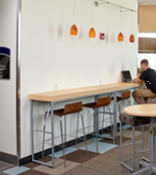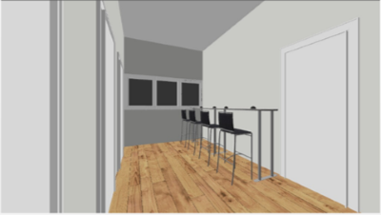
Concept Photo
3D Rendering: This seating area would be ideal for students to study, work on a laptop, or charge devices while they wait to meet with instructors or for a class to start.

The Global Swap Table 30”d x 96”w x 42”h and four Ki Strive stools would be perfect for this space.
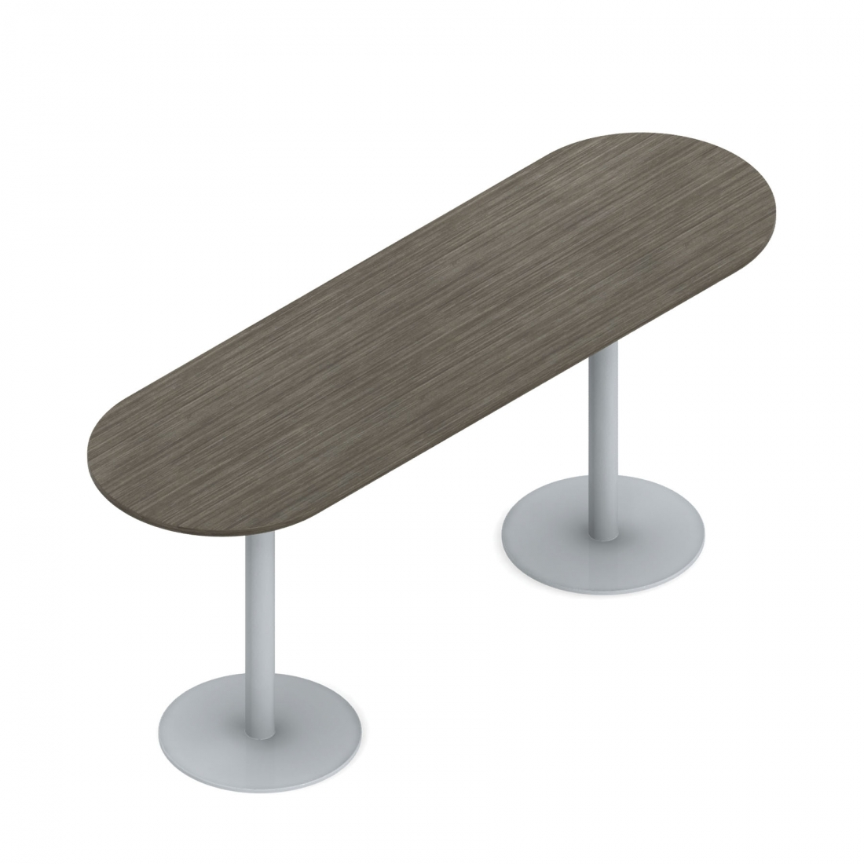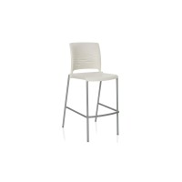

Central Area
The corner nook toward the left hallway (if facing the central windows) would be ideal for a table with four chairs. Since there would be bar-height seating in the alcove, this table would be regular table height to allow for wheelchair accessibility. Wiring for two outlets could be extended along both walls of this corner.
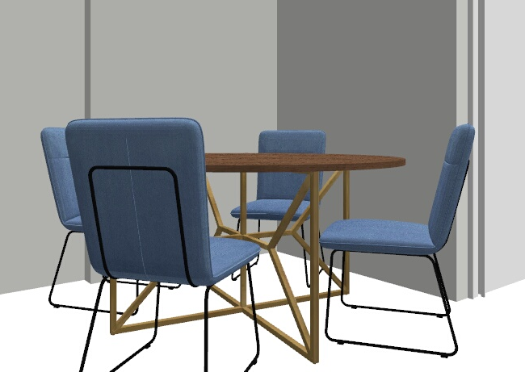
3D Rendering: This area would serve as an additional, accessible study, waiting, or device charging area.
Concept Photo

The Global Swap round table (36”x36”x36”) and four Ki Strive chairs would work well in this area.
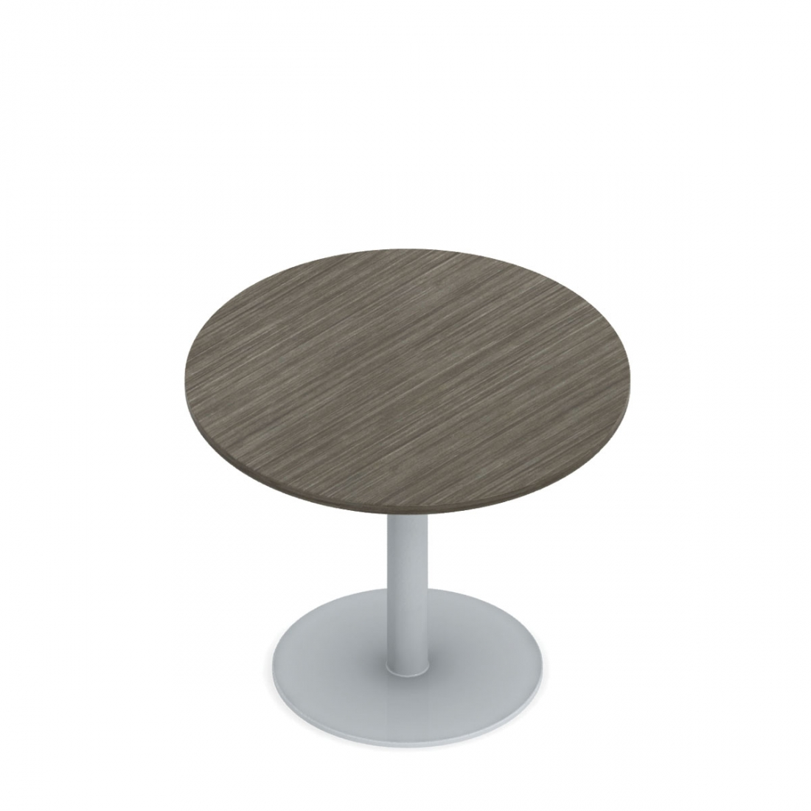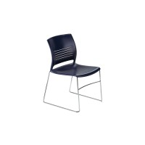
The corner nook toward the right hallway would serve as a spot for two benches, an ottoman, and two outlets. There is also the possibility of a small table between the benches, although that has not been quoted at this time. Other than running wires for outlets on the two walls, the only other OM task would be to relocate the red fire extinguisher box from this wall to a wall in the nearby alcove.
Concept Photo: Actual Product
3D Rendering: Seating with charging outlets added on walls.

Two Global Citi benches and an OFS Boost Round Ottoman are suggested items for this corner. Both pieces can be upholstered in a durable vinyl that can be cleaned easily with Clorox-type wipes.

The last item for this upstairs area would be a wall mounted magazine rack to hold course advertisements and information sheets to assist students in choosing courses. This would be mounted on the wall near the restrooms.
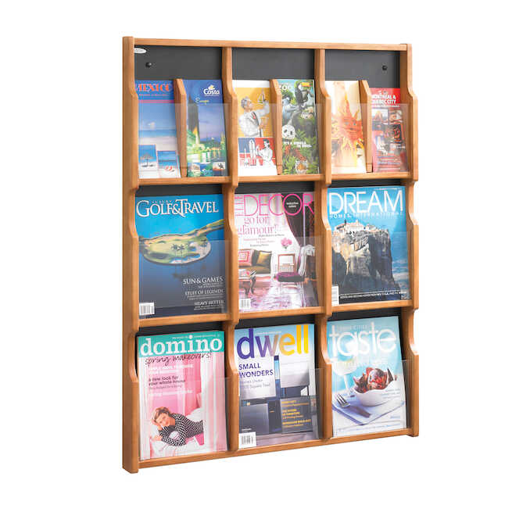
Safco product (no quoted price given yet.)
Demco product

Price Breakdown: (As of 2019)

BDH 2nd Floor Central Area

Alcove by front window
Item | Size | QTY | Price Per Item | Total
Global Swap Table | 30x96x42h | 1 | $1,070.00 | $1,070.00
Ki Strive Café Stool (poly café stool) |  | 4 | $185.00 | $740.00
Central Area
Global Swap Table | 36x36x36 | 1 | $494.45 | $494.45
Ki Strive Chair |  | 4 | $133.90 | $535.60
Citi Two Seat Bench | 43x21.5x17 | 2 | $449.90 | $899.80
OFS Boost Round Ottoman | 25.5x25.5x17.75 | 1 | $522.50 | $522.50
Wooden Mallett Oak & Acrylic Wall Display | Demco | 1 | $284.99 | $284.99
 |  |  |  | $4547.34
Budget Breakdown | Budgeted | Spent
Original Budget (Dr. Owens) | $3000.00 | $3000.00
Communications Budget Goal 2 OBJ 4 | $1000.00 | $773.67
Communications Budget Goal 2 OBJ 6 | $300.00
Liberal Arts Budget Goal 2 OBJ 4 | $1000.00 | $773.67
Liberal Arts Budget Goal 2 OBJ 6 | $300.00
TOTAL | $5,600.00 | $4,547.34
*Budgeted amount has been raised to account for anticipated price increases.

Classroom Furniture P.O. from April 2021
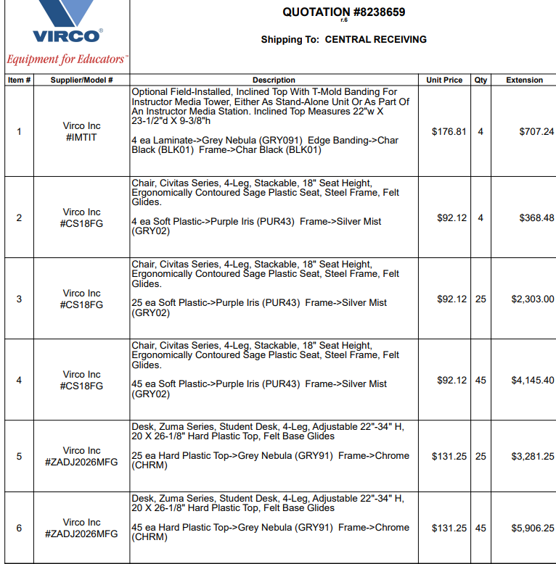
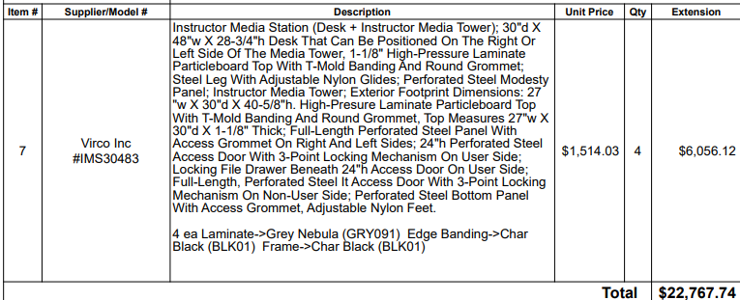

I met with Lynn Harris regarding the feasibility of adding 7-8 outlets with USB charging capabilities in this area. He said that he could drop the wires from the ceilings and cover them with wire covers painted to match the décor.

