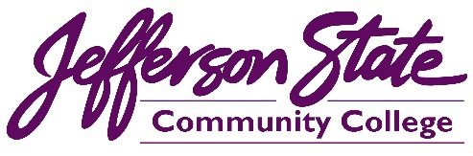 |  |  | Goal Progress Report
Program: | Community & Media Relations | Report period: |  | 2021-2022

Goals | Request & Justification/Resources | Goal Progress | Strategies Implemented & Follow-up
Further develop the effectiveness of the college’s advertising and marketing by increasing reach, frequency, and engagement by 20 percent | The office requested and received an increase in the overall advertising budget by $50,000. | With the increase in the college’s advertising budget, the college is on track to achieve this goal. An increase in funding helped increase the reach and frequency of radio, TV, and digital advertising. It also allows our office to increase advertising for non-credit programs. | The office will continue to create and monitor advertising to produce the highest possible ROI.
Keep the college website updated, accurate, and interesting for current students, prospective students, and the community. | No additional request. | With constant monitoring, updates, and additions, the college website provides current and relevant information regarding offerings, opportunities, and more. | Our office has made significant enhancements to the college website, including a looping video on the home page to highlight various programs, opportunities, and activities. The office will continue to monitor and update the college website daily.
Increase the college’s social media engagement by 20 percent to help promote and advertise the opportunities and happenings of the college. | The new graphic designer position in our office has produced professional graphics for our website, videos, social media, and printed materials for both recruiting and events. These graphics have helped improve the look, engagement, and reach across all social media platforms and has helped our office make great progress toward this goal. | With improved graphics and design on the college’s social media (including videos, posts, ads, infographics, and boosted content) the college is on pace to meet this goal. | The office will review analytics for each social media page paypaid to advertise.
Increase promotion of the college’s CTE programs and non-credit fast-track programs. | Additional advertising funds and additional personnel have helped our office provide more advertising for these programs. | The office has increased awareness of the college’s CTE and Fast-Track programs with more news coverage, paid advertising, articles, videos, social media, and more. | The office will continue to promote all CTE programs and Fast-Track programs with a wide array of marketing strategies.
Build positive relationships for the college by working to meet the needs of various groups both on and off campus. | No additional request. | The Office participates in various community organizations and efforts. Our office will continue to participate in community endeavors to help highlight the college as an active community partner. | The Office will maintain memberships in chambers of commerce, participate in community initiatives, and more.
Develop a campus seminar and internal website to assist college personnel in marketing their programs, groups, or clubs. | No additional request. | The office has not finished this goal. We have not yet initiated an on-campus seminar to help groups better market their programs. We plan to utilize the new graphic designer/social media technician position in this effort. | The office will continue to develop this initiative. The hope is this effort will help protect and maintain college branding in all promotion of college programs, organizations, or student clubs.
Develop an improved project management system to help streamline workflow on various projects in our office. | No additional request. | This new online system will be managed, in large part, by a new employee that is being added to our office. The new position will be a Coordinator of Community & Media Relations. | The new system will be taught to the new position and monitored by all positions in the Office. Changes and improvements to the system will be implemented as necessary.
Submission date: December 15, 2022 |  | 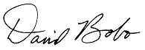  Submitted by:

