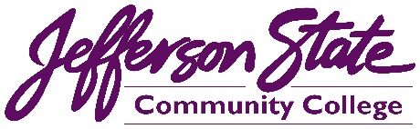 |  |  | Goal Progress Report
Program: | Community & Media Relations | Report period: |  | 2020-2021

Goals | Request & Justification/Resources | Goal Progress | Strategies Implemented & Follow-up
Further develop the effectiveness of the college’s advertising and marketing by increasing reach, frequency, and engagement by 20 percent. | The office requested and received an increase in the overall advertising budget by $50,000. | With the increase in the college’s advertising budget, the college is on track to achieve this goal. An increase in funding helped increase the reach and frequency of radio, TV, and digital advertising. | The office will continue to create and monitor advertising to produce the highest possible ROI.
Keep the college website updated, accurate, and interesting for current students, prospective students, and the community. | No additional request. | With constant monitoring, updates, and additions, the college website provides current and relevant information regarding offerings, opportunities, and more. | The office will continue to monitor and update the college website daily.
Increase the college’s social media engagement by 20 percent to help promote and advertise the opportunities and happenings of the college. | The new digital media specialist position in our office has produced captivating videos and graphics for our website and social media. These videos and graphics have improved engagement and reach across all social media platforms and have helped our office make great strides toward this goal. | With an increase in content on the college’s social media (including videos, posts, ads, infographics, and boosted content) the college is on pace to meet this goal. | The office will review analytics for each social media page and pay to advertise.
Increase promotion of the college’s CTE programs, including the college’s new Welding Program at the Shelby-Hoover Campus. | Additional advertising funding will help provide for more advertising of these programs. | The office has successfully increased awareness of the new welding center at the Shelby-Hoover Campus. News articles, videos, social media, and a grand opening event have been produced to create awareness of the center. Videos, articles, social media, and more have also been created for the college’s CTE programs. | The office will continue to promote the new facility and all CTE programs with marketing and advertising.
Build positive relationships for the college by working to meet the needs of various groups both on and off campus. | No additional request. | The Office participates in various community organizations/efforts and will continue to demonstrate the college is an active community partner. | The office will maintain memberships in chambers of commerce, participate in community initiatives, and more.
Develop a campus seminar and internal website to assist college personnel in marketing their programs, groups, or clubs. | No additional request. | The office has not finished this goal. We have not initiated an on-campus seminar to help groups better market their programs. We plan to utilize the new graphic designer/social media technician position in this effort. | The office will continue to develop this initiative. The hope is this effort will help protect and maintain college branding in all promotion of college programs, organizations, or student clubs.
Submission date: August 30, 2021 |  | 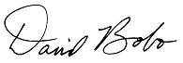  Submitted by:

